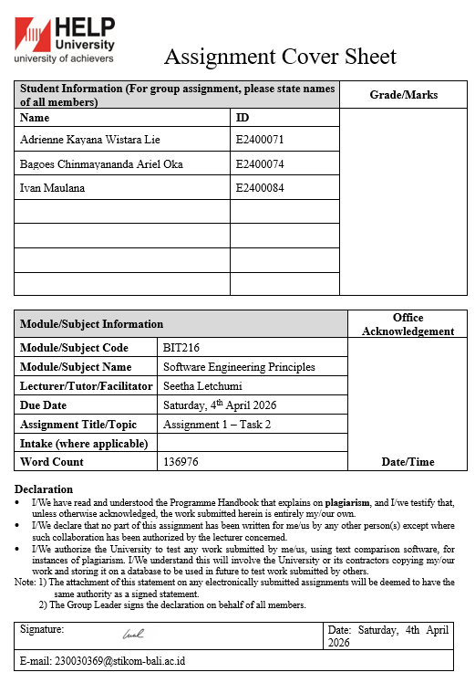
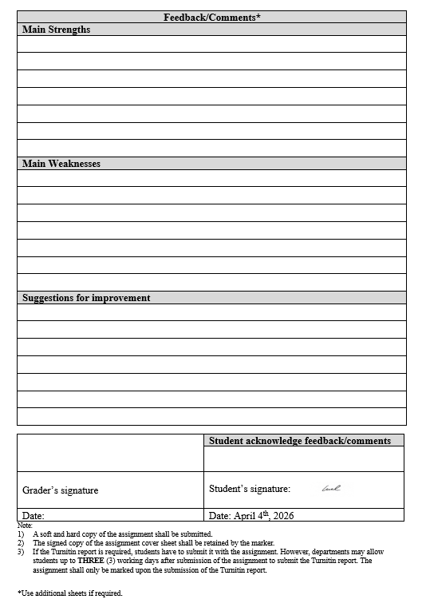


Save Plate - Smart Food Waste Reduction App

BIT216 Software Engineering Principles

Team Leader:
E2400084 Ivan Maulana
Team Member:
E2400074 Bagoes Chinmayananda Ariel Oka
E2400071 Adrienne Kayana Wistara Lie

Contact:
ivanmaulana22sch@gmail.com
230030369@stikom-bali.ac.id
adrikayanacollege@gmail.com

BACHELOR OF INFORMATION TECHNOLOGY (HONS)
HELP UNIVERSITY
APRIL 2026
Table of Contents
1. Requirement Specification Document 1
1.1. Functional and Non-Functional Requirements 1
1.1.1 Functional Requirements 1
1.1.2 Non-Functional Requirements 9
1.2. Modeling the requirements 15
1.2.1. Epic + User Stories + Acceptance Criteria + Tasks 15
1.2.1.1 Use Case 1: Register User and Privacy Settings (Ivan Maulana) 15
1.2.1.2 Use Case 2: Manage Food Inventory (Ivan Maulana) 19
1.2.1.3 Use Case 3: Browse Food Items (Bagoes Chinmayananda Ariel Oka) 26
1.2.1.4 Use Case 4: Food Analytics (Bagoes Chinmayananda Ariel Oka) 31
1.2.1.5 Use Case 5: View Notifications (Adrienne Kayana Wistara Lie) 35
1.2.1.6 Use Case 6: Plan Weekly Meals (Adrienne Kayana Wistara Lie) 42
2. Design Specification Document (Group Work) 49
2.1. Derive the Architectural Design 49
2.2. High level design components 50
2.2.1. ERD (conceptual view of the data storage) 50
2.2.2. Site Map (hierarchy diagram) 51
2.2.3. Generic User Experience/Wireframe etc – (canva/pencil,figma) 52
3. System design of the application 59
3.1 Database Design (Data Dictionary) 59

Table of Figures
Figure 1.2.1-1 Architectural Design 49
Figure 2.2.1-1 ERD Diagram 50
Figure 2.2.2-1 Site Map 51
Figure 2.2.3-1 Error Page 52
Figure 2.2.3-2 Login Page 52
Figure 2.2.3-3 Sign Up Page 53
Figure 2.2.3-4 Authentication Page (2FA) 53
Figure 2.2.3-5 Dashboard 54
Figure 2.2.3-6 Notification 54
Figure 2.2.3-7 Food Inventory Page 55
Figure 2.2.3-8 Add Food Item to Inventory 55
Figure 2.2.3-9 Donate Item from Inventory 56
Figure 2.2.3-10 Browse Food Page (Available to claim from another user inventory) 56
Figure 2.2.3-11 Meal Planner Page 57
Figure 2.2.3-12 Add Meal Plan (Based from food on inventory) 57
Figure 2.2.3-13 Food Analytics Page (Reports) 58
Figure 2.2.3-14 Settings Page 58

Table of Tables
Table 1.1.1-1 Functional Requirements 1
Table 1.1.1-2 Register User and Privacy Settings 2
Table 1.1.1-3 Manage Food Inventory 3
Table 1.1.1-4 Browse Food Items 4
Table 1.1.1-5 Food Analytics 5
Table 1.1.1-6 View Notifications 6
Table 1.1.1-7 Plan Weekly Meals 7
Table 1.1.2-1 Non-Functional Requirements 9
Table 1.1.2-2 Security 10
Table 1.1.2-3 Usability 11
Table 1.1.2-4 Reliability 11
Table 1.1.2-5 Scalability 12
Table 1.1.2-6 Maintainability 13
Table 1.2.1-1 Epic1 – User Account Registration & Security 15
Table 1.2.1-2 User Story – Account Registration 15
Table 1.2.1-3 User Story – Two Factor Authentication (2FA) Setup 16
Table 1.2.1-4 User Story – Privacy Settings & Food Lising Visibility 18
Table 1.2.1-5 Epic 2 – Household Food Inventory Management 19
Table 1.2.1-6 User Story – Add a New Food Item to Inventory 19
Table 1.2.1-7 User Story – View, Edit and Delete Inventory Item 22
Table 1.2.1-8 User Story – Mark an Item as Used or Consumed 23
Table 1.2.1-9 User Story – Convert a Near Expiry Item to a Donation Listing 25
Table 1.2.1-10 Epic 1 – Food Item Discovery & Donation Browsing 26
Table 1.2.1-11 User Story – Browse and Filter Available Food Listing 27
Table 1.2.1-12 User Story – View Full Item Detail and Take Action 28
Table 1.2.1-13 User Story – Request and Claim a Donation Listing 30
Table 1.2.1-14 Epic 2 – Food Waste Tracking & Analytics Dashboard 31
Table 1.2.1-15 User Story – View Food Savings Summary Dashboard 32
Table 1.2.1-16 User Story – Filter Analytics by Date Range and Category 33
Table 1.2.1-17 User Story – View Progress Indicators and Milestones 34
Table 1.2.1-18 Epic 1 – Real Time Alerts & Notification Centre 35
Table 1.2.1-19 User Story – View All Notifications in the Notification Centre 36
Table 1.2.1-20 User Story – Interact with Notifications via Deep Links 37
Table 1.2.1-21 User Story – Mark Notification as Read (Individual and Bulk) 39
Table 1.2.1-22 User Story – Manage Notification Preferences 40
Table 1.2.1-23 Epic 2 – Inventory Based Weekly Meal Planning 42
Table 1.2.1-24 User Story – View Weekly Meal Planning Calendar 42
Table 1.2.1-25 User Story – Add Meals Manually or via Recipe Suggestions 44
Table 1.2.1-26 User Story – Confirm Meal Plan and Reserve Inventory 46
Table 1.2.1-27 User Story – Receive Meal Planning Reminders from Expiry Alerts 47
Table 2.2.3-1 Entity: User 59
Table 2.2.3-2 Entity: FoodItem 60
Table 2.2.3-3 Entity: Donation 61
Table 2.2.3-4 Entity: MealPlan 62
Table 2.2.3-5 Entity: MealPlanItem 63
Table 2.2.3-6 Entity: Notification 64

Requirement Specification Document

Functional and Non-Functional Requirements

Functional Requirements
Functional requirements define the specific behaviours and functions the SavePlate system must provide to support its six core use cases. Each requirement below is identified by a unique ID, specifies the system's observable behaviour, provides the justification for its inclusion, and is assigned a MoSCoW priority M (Must Have), S (Should Have), or C (Could Have) to guide iterative development planning. Requirements are grouped by use case and student responsibility as established in the Task 2 assignment brief.
Table 1.1.1-1
Functional Requirements
Priority | Definition | Application in SavePlate
M - Must Have | Critical to the current delivery of software. The system is not usable without these requirements. | Core registration, inventory CRUD, browse, notification delivery, meal calendar
S - Should Have | Important but not necessary for the current release. High value; can be deferred to next iteration without breaking core functionality. | 2FA setup, donation conversion, claiming listings, plan confirmation, notification read-state
C - Could Have | Desirable but not necessary. Included if time and resources allow; deferred without significant impact on current release value. | Granular privacy settings, analytics filtering, milestone badges, notification preferences, expiry-triggered suggestions

Table 1.1.1-2
Register User and Privacy Settings
UC1: Register User and Privacy Settings
Responsible Student: Ivan Maulana (E2400084)
FR ID | Requirement | Rationale | Priority
FR-1.1 | The system must allow new household users to create an account by entering their full name, email address, and password. The password must follow basic security rules such as having at least eight characters, including one uppercase letter and one number. | Account registration is the starting point for users to use the system. All main features such as managing inventory, donating food, and planning meals can only be accessed after the user has an account. | M  Must Have
FR-1.2 | After the user submits the registration form, the system must send a six-digit One-Time Password to the registered email. The user must enter the correct code before the account can be activated. | This step helps to confirm that the email entered is valid and belongs to the user. It also reduces the risk of incorrect or fake account registration. | M  Must Have
FR-1.3 | The system should allow users who are already logged in to enable Two-Factor Authentication through the security settings. When this feature is turned on, the system will send a six-digit One-Time Password to the user’s email during login, and access will only be given after the code is verified. | This adds an extra level of security to protect user accounts, especially since the system stores personal and household-related information. | S  Should Have
FR-1.4 | The system should allow users to manage their privacy settings from the dashboard. Users can choose the visibility of their donation listings, such as Public, Community Only, or Private. They can also decide whether their full name and location are shown. | This allows users to control how their personal information is shared with others, especially when their food listings are visible in the system. | C  Could Have
FR-1.5 | When users update their privacy settings, the changes must be applied automatically to all their existing and future donation listings without requiring manual updates. | This ensures that privacy settings are applied consistently. Users do not need to edit each listing one by one after making changes. | C  Could Have

Table 1.1.1-3
Manage Food Inventory
UC2: Manage Food Inventory
Responsible Student: Ivan Maulana (E2400084)
FR ID | Requirement | Rationale | Priority
FR-2.1 | The system must allow a logged-in user to add a new food item into their personal inventory. The user must provide details such as item name, quantity with unit, expiry date (which must not be in the past), and food category. Storage location and notes can be added optionally. | Correct data entry is important because all system features depend on it. Functions such as expiry alerts, meal planning, donation, and analytics rely on accurate information from the inventory. | M  Must Have
FR-2.2 | The system must display the user’s full inventory list. Users should be able to view, sort items by expiry date, name, or category, edit item details, and delete items with a confirmation before removal. | Food items in a household are always changing. Users need to update their inventory regularly so that the system can provide accurate reminders and suggestions. | M  Must Have
FR-2.3 | The system must allow users to mark a food item as used or consumed. After confirmation, the item status will be updated, removed from the active list, and recorded for analytics purposes. | This feature helps the system track how much food is successfully used instead of wasted, which will later be shown in the analytics dashboard. | M  Must Have
FR-2.4 | The system should allow users to convert an inventory item into a donation listing by providing pickup location, availability time, and storage details. The item status will be updated and made visible to other users based on privacy settings. | This feature connects users who have extra food with others in the community, supporting the goal of reducing food waste through sharing. | S  Should Have
FR-2.5 | The system must not allow deletion of items that are currently reserved for a meal plan. A warning message should be shown, asking the user to remove the item from the meal plan first. | This rule prevents errors in the system, where a meal plan could reference an item that no longer exists. | M  Must Have

Table 1.1.1-4
Browse Food Items
UC3: Browse Food Items
Responsible Student: Bagoes Chinmayananda Ariel Oka (E2400074)
FR ID | Requirement | Rationale | Priority
FR-3.1 | The system must allow users to browse all available food items, including their own inventory and community donation listings. Each item should display key details such as name, quantity, expiry date, category, storage type, and source. | A combined view makes it easier for users to check both their own items and available donations without switching pages. | M  Must Have
FR-3.2 | The system must provide filtering options such as source, category, expiry range, and storage type. Only items that match the selected filters will be shown. | Filters help users find relevant items faster, especially when dealing with many items. | M  Must Have
FR-3.3 | The system must allow users to click an item to see full details and available actions. Actions differ depending on the item, such as marking as used, adding to a meal plan, converting to donation, or claiming an item. | Providing actions directly from the item view helps users respond quickly, especially for items close to expiry. | M  Must Have
FR-3.4 | The system should allow users to claim a donation item. Once claimed, the item status is updated, and both the donor and the user will receive notifications. | This completes the donation process and ensures both parties are informed for further coordination. | S  Should Have
FR-3.5 | The system must display expiry indicators using colours to show urgency, such as red for urgent items, amber for items expiring soon, and green for safe items. | Visual indicators help users quickly identify which items need attention without checking each date manually. | M  Must Have

Table 1.1.1-5
Food Analytics
UC4: Food Analytics
Responsible Student: Bagoes Chinmayananda Ariel Oka (E2400074)
FR ID | Requirement | Rationale | Priority
FR-4.1 | The system should provide a dashboard that shows summary information such as total food used, total donations made, and activity charts over the past 30 days. | A visual summary helps users understand their contribution in reducing food waste and encourages continued use of the system. | S  Should Have
FR-4.2 | The system should allow users to filter analytics data by time period and category. The dashboard should update based on the selected filters. | Filtering helps users identify patterns and improve their habits based on specific time or food types. | C  Could Have
FR-4.3 | The system should show comparisons between current and previous periods, including percentage changes in food usage and donations. | Comparisons help users understand their progress over time, which can motivate improvement. | S  Should Have
FR-4.4 | The system should include achievement badges and progress tracking for milestones such as number of items saved or donations made. Notifications should appear when a milestone is reached. | Rewards and achievements can encourage users to stay active and continue using the system. | C  Could Have
FR-4.5 | The system must display a helpful message if there is no data available, encouraging users to start using the features. | This prevents confusion and guides new users on what to do next. | M  Must Have

Table 1.1.1-6
View Notifications
UC5: View Notifications
Responsible Student: Adrienne Kayana Wistara Lie (E2400071)
FR ID | Requirement | Rationale | Priority
FR-5.1 | The system must provide a notification centre that shows all alerts in order, including type, message, time, and read or unread status. | Notifications are important to inform users about important updates and time-sensitive actions. | M  Must Have
FR-5.2 | The system must automatically generate notifications such as expiry alerts, donation updates, meal reminders, and account-related alerts. | Each type of notification supports a different function, from preventing waste to maintaining account security. | M  Must Have
FR-5.3 | The system must allow users to click a notification and be directed to the related page. The notification should then be marked as read. | This helps users take action quickly without searching manually. | M  Must Have
FR-5.4 | The system should allow users to mark notifications as read individually or all at once. The notification count should update immediately. | This helps users manage their notifications more easily. | S  Should Have
FR-5.5 | The system should allow users to control which notifications they receive through settings. Disabled notifications should not be sent. | This prevents users from feeling overwhelmed by too many notifications. | C  Could Have

Table 1.1.1-7
Plan Weekly Meals
UC6: Plan Weekly Meals
Responsible Student: Adrienne Kayana Wistara Lie (E2400071)
FR ID | Requirement | Rationale | Priority
FR-6.1 | The system must provide a weekly meal planner with seven days and meal slots, along with a panel showing available inventory sorted by expiry date. | This layout helps users plan meals while considering which items need to be used soon. | M  Must Have
FR-6.2 | The system must allow users to add meals manually or choose from suggested recipes based on available ingredients, prioritising items close to expiry. | This feature helps reduce food waste by encouraging users to use ingredients before they expire. | M  Must Have
FR-6.3 | The system should allow users to confirm their meal plan. After confirmation, related items will be marked as reserved and notifications will be scheduled. | This ensures that selected ingredients are not used elsewhere and keeps the system consistent. | S  Should Have
FR-6.4 | The system should allow users to view previous or future weeks and keep saved meal plans. | This supports long-term planning and allows users to review past meals. | S  Should Have
FR-6.5 | The system should send a suggestion notification when an item is close to expiry and has not been used or planned. The notification should include quick links to relevant pages. | This encourages users to take action before food is wasted. | C  Could Have

Non-Functional Requirements
Non-functional requirements describe the quality standards and system constraints that SavePlate must meet. These requirements focus on how the system operates rather than what features it provides. They cover aspects such as performance, security, usability, reliability, scalability, and maintainability. Each requirement also includes measurable criteria so that the system can be properly evaluated during testing. Unless stated otherwise, these requirements apply to the entire system.
Table 1.1.2-1
Non-Functional Requirements
NFR Category: Performance
NFR ID | Requirement | Rationale | Measurable Metric
NFR-PE-1 | The system must load the Food Inventory dashboard within 3 seconds for users who have up to 200 items, using a normal internet connection (at least 10 Mbps). | The inventory page is the most frequently accessed part of the system. If it takes too long to load, users may lose interest or leave the application. | Page load time ≤ 3 seconds under normal conditions
NFR-PE-2 | The system must return API responses for data requests (such as inventory, browse, notifications, and analytics) within 1.5 seconds when up to 50 users are accessing the system at the same time. | Fast API responses are important to ensure smooth interaction. Slow responses can cause delays when users navigate or perform actions. | API response time ≤ 1.5 seconds with 50 concurrent users
NFR-PE-3 | The system must run the daily background process that checks for expiring items and sends alerts within 5 minutes of the scheduled time. | Expiry notifications must be delivered on time. Delays can cause users to miss important reminders, leading to wasted food. | Background process completes within 5 minutes of schedule

Table 1.1.2-2
Security
NFR Category: Security
NFR ID | Requirement | Rationale | Measurable Metric
NFR-SE-1 | The system must store all user passwords in encrypted form using bcrypt with a minimum cost factor of 12. Plaintext passwords must never be stored or exposed. | Protecting user credentials is essential to prevent data breaches and unauthorized access. | Zero plaintext passwords in database or logs; bcrypt cost factor ≥ 12
NFR-SE-2 | The system must secure all protected API endpoints using JSON Web Tokens with a maximum validity of 24 hours. Invalid or missing tokens must result in an unauthorized response. | This ensures that only authenticated users can access protected data and reduces risk if a token is compromised. | All protected endpoints require valid token; token validity ≤ 24 hours
NFR-SE-3 | The system must ensure that all communication between client and server uses HTTPS with TLS 1.2 or higher. All HTTP requests must be redirected to HTTPS. | Secure communication prevents sensitive data from being intercepted during transmission. | Zero non-HTTPS API requests accepted; TLS version ≥ 1.2
NFR-SE-4 | The system must ensure that users can only access and modify their own data. Any attempt to access another user’s data must be blocked. | This protects user privacy and prevents unauthorized data access. | All unauthorized access attempts rejected

Table 1.1.2-3
Usability
NFR Category: Usability
NFR ID | Requirement | Rationale | Measurable Metric
NFR-US-1 | The system must show clear error messages next to input fields when validation fails, without removing correctly entered data. | Clear feedback helps users correct mistakes easily and improves the overall experience. | All validation errors include clear messages
NFR-US-2 | The system must display a loading indicator when data is being retrieved, appearing quickly after the user performs an action. | Loading indicators help users understand that the system is processing their request. | Loading indicator appears within 200 ms
NFR-US-3 | The system must work properly on the latest versions of Chrome and Edge across different screen sizes without layout issues. | Ensures that most users can access the system without visual or functional problems. | No layout issues across supported screen sizes
NFR-US-4 | The system must show a helpful message when no data is available, including guidance on what the user can do next. | This prevents confusion and helps guide users, especially new ones. | All empty pages include guidance message

Table 1.1.2-4
Reliability
NFR Category: Reliability
NFR ID | Requirement | Rationale | Measurable Metric
NFR-RE-1 | The system must maintain at least 95% uptime during testing and demonstration, with no downtime longer than 30 minutes. | Ensures the system is available when needed, especially during demonstrations. | System uptime ≥ 95%; maximum single outage duration ≤ 30 minutes
NFR-RE-2 | The system must handle errors properly so that failures do not crash the server. All errors must be logged and return a clear response. | Prevents the entire system from stopping due to a single error. | No crashes caused by unhandled errors
NFR-RE-3 | The system must validate all incoming data on the server side and reject invalid requests with proper error messages. | Server-side validation ensures data integrity even if client validation is bypassed. | All invalid requests return error responses

Table 1.1.2-5
Scalability
NFR Category: Scalability
NFR ID | Requirement | Rationale | Measurable Metric
NFR-SC-1 | The MongoDB database schema shall be designed to support a minimum of 1,000 users, each with up to 500 food inventory items, without requiring structural schema changes; queries on the foodItems collection shall use indexed fields (userId, expiryDate, status, category) to maintain query performance at this scale. | Index design decisions made during development are difficult to change in production. Defining the required indexes now, based on the most common query patterns (filtering by userId, sorting by expiryDate, filtering by status), prevents performance degradation as data volume grows. | Required indexes defined for userId, expiryDate, status, and category fields in foodItems collection
NFR-SC-2 | The Vue.js frontend application shall be built as a Single Page Application (SPA) with code splitting enabled, such that the initial JavaScript bundle size does not exceed 500 KB (gzipped), and individual route chunks are loaded on demand rather than bundled into a single file. | A monolithic JavaScript bundle forces users to download the entire application before any content renders. Code splitting allows the initial load to deliver only what is needed for the landing/login page, with route-specific code loaded lazily as the user navigates. | Initial gzipped JS bundle ≤ 500 KB; route-level code splitting implemented

Table 1.1.2-6
Maintainability
NFR Category: Maintainability
NFR ID | Requirement | Rationale | Measurable Metric
NFR-MA-1 | The Express.js backend codebase shall be organised using a layered architecture separating routes, controllers, services, and data models into distinct directories; no business logic shall be placed directly inside route handler functions. | Separation of concerns reduces coupling and makes the codebase easier to test, modify, and extend. Business logic embedded in route handlers is a common anti-pattern that makes unit testing impossible and future feature additions unnecessarily difficult. | Codebase structure: /routes, /controllers, /services, /models directories present and correctly used
NFR-MA-2 | All source code shall be version-controlled using Git and hosted on the team's designated GitHub repository (as established in Task 1); each meaningful feature or fix shall be committed with a descriptive commit message, and the main branch shall only receive changes via pull requests reviewed by at least one team member. | Version control is a non-negotiable professional standard. The pull-request workflow ensures code review occurs before integration, reducing bugs reaching the main branch and creating a documented history of all changes which also satisfies the assignment's requirement for evidence of teamwork. | 100% of code changes committed to GitHub; pull-request workflow followed for main branch

Modeling the requirements

Epic + User Stories + Acceptance Criteria + Tasks

Use Case 1: Register User and Privacy Settings (Ivan Maulana)
Table 1.2.1-1
Epic1 – User Account Registration & Security
[Epic 1] User Account Registration & Security
Feature/Functionality:
Enable new household users to create a verified SavePlate account and configure security and privacy settings (including Two-Factor Authentication and food listing visibility) so that their personal data and household information remain protected throughout their use of the platform.

Table 1.2.1-2
User Story – Account Registration
User Story | As a new household user,  I need the ability to register a personal account on SavePlate by providing my name, email address, and password,  so that I can access the platform's food management features and securely store my household data.
Acceptance Criteria | Given the user has navigated to the SavePlate registration page and has not yet created an account,  When the user enters a valid full name, a unique email address, and a password that meets the minimum security requirements (minimum 8 characters, at least one uppercase letter and one number), and submits the form,  Then the system shall validate all inputs, create the user record in the database, send a 6-digit email verification code to the registered email address, and display a confirmation message instructing the user to verify their email before proceeding.
MoSCoW Priority | M - Must Have  Account registration is a prerequisite for every other feature in SavePlate. Without it, no user can access inventory, donations, or meal planning.
Tasks | - Design the registration form UI in Vue.js with fields: Full Name, Email, Password, Confirm Password, and optional Household Size  - Implement client-side validation: required fields, email format check (regex), password strength rules  - Create POST /api/auth/register endpoint in Express.js that receives user data and validates uniqueness of email  - Hash user password using bcrypt before storing in MongoDB users collection  - Implement email verification service: generate a 6-digit OTP, store with expiry timestamp, send via NodeMailer/SendGrid  - Build email verification page in Vue.js where the user enters the OTP code  - On successful OTP verification, update user document status to 'verified' and redirect to dashboard  - Write unit tests for registration endpoint (valid inputs, duplicate email, weak password)
Test Cases | [Leave Blank — to be filled in Assignment 2]

Table 1.2.1-3
User Story – Two Factor Authentication (2FA) Setup
User Story | As a registered household user,  I need the ability to enable Two-Factor Authentication (2FA) on my SavePlate account via email verification,  so that I can ensure my account and household data remain secure even if my password is compromised.
Acceptance Criteria | Given the user is logged in and navigates to the Security Settings section of their account dashboard,  When the user toggles the 2FA option to enabled and confirms by entering their current password,  Then the system shall save the 2FA preference to the user's profile, and on all subsequent login attempts, the system shall send a one-time 6-digit code to the user's registered email and require its entry before granting access to the dashboard.
MoSCoW Priority | S - Should Have  2FA significantly improves account security and is important for protecting sensitive household and location data, but the core registration flow can operate without it in the initial release.
Tasks | - Add 'is2FAEnabled' boolean field to the users MongoDB collection schema  - Build a Security Settings page in Vue.js with a 2FA toggle switch and password confirmation prompt  - Create PATCH /api/user/settings/2fa endpoint in Express.js to update the user's 2FA preference  - Modify the login flow: after successful password verification, check if is2FAEnabled is true; if so, generate OTP and send to email before issuing JWT token  - Build the 2FA code entry page in Vue.js for the login flow  - Implement OTP expiry logic (5-minute validity) and resend option with rate limiting  - Store 2FA OTP in a temporary cache/session (not permanent DB) and clear after successful validation
Test Cases | [Leave Blank — to be filled in Assignment 2]

Table 1.2.1-4
User Story – Privacy Settings & Food Lising Visibility
User Story | As an authenticated household user,  I need the ability to configure my privacy settings, including controlling the visibility of my food donation listings and managing what personal information is shared with other users,  so that I can participate in the SavePlate community while maintaining control over my personal and household privacy.
Acceptance Criteria | Given the user is logged in and accesses the Privacy Settings section from the account dashboard,  When the user modifies any privacy option (e.g., sets listing visibility to 'Community Only' or 'Private', or disables display of their full name on donation listings) and clicks Save,  Then the system shall immediately persist the updated privacy settings to the user's profile in the database, apply the new visibility rules to all existing and future listings, and display a success confirmation message to the user.
MoSCoW Priority | C - Could Have  Granular privacy controls enhance user trust and are desirable, but simplified defaults (e.g., 'Community Only' by default) can serve most users without a full settings interface in the initial release.
Tasks | - Add 'privacySettings' sub-document to users collection: { listingVisibility: enum['public','community','private'], showFullName: boolean, showLocation: boolean }  - Build Privacy Settings page in Vue.js with radio buttons/toggles for each privacy option  - Create PATCH /api/user/settings/privacy endpoint in Express.js  - Update the donations query logic to filter listings based on the donor's listingVisibility setting  - Mask or omit personal details in donation listing API responses based on donor privacy preferences  - Ensure privacy settings are applied retroactively to all existing donation listings when updated
Test Cases | [Leave Blank — to be filled in Assignment 2]

Use Case 2: Manage Food Inventory (Ivan Maulana)
Table 1.2.1-5
Epic 2 – Household Food Inventory Management
[Epic 2] Household Food Inventory Management
Feature/Functionality:
Allow authenticated household users to maintain a complete and accurate digital record of all food items stored in their household including item name, quantity, expiry date, category, and storage location. Users can add new items, edit existing records, mark items as used or consumed, and seamlessly convert near-expiry items into donation listings. The inventory serves as the central data source for expiry alerts, meal planning suggestions, donation management, and food analytics across the entire SavePlate platform.

Table 1.2.1-6
User Story – Add a New Food Item to Inventory
User Story | As an authenticated household user,  I need the ability to add a new food item to my personal SavePlate inventory by entering its name, quantity, expiry date, food category, and optional storage location and notes,  so that the system has an accurate and up-to-date record of my household food stock that can be used for expiry alerts, meal planning, and donation management.
Acceptance Criteria | Given the user is logged in and navigates to the 'Food Inventory' section, then clicks the 'Add Food Item' button,  When the user completes the form by entering the item name (required), quantity (required), expiry date (required), food category (required e.g., Vegetables, Dairy, Canned, Frozen, Bakery), storage location (optional e.g., Fridge, Freezer, Pantry), and any additional remarks, then submits the form,  Then the system shall validate all required fields, reject the submission with an inline error message if any required field is missing or if the expiry date is set to a past date, and on valid input save the new food item document to the foodItems MongoDB collection with status set to 'available', then immediately display the new item in the inventory list and show a success toast notification: 'Food item added successfully.'
MoSCoW Priority | M - Must Have  Adding food items is the foundational action of the entire inventory system. Every other feature in SavePlate expiry alerts, meal planning, donation listings, and analytics depends on food items being recorded here. Without this capability the platform has no data to operate on.
Tasks | - Design the 'Add Food Item' form page or modal in Vue.js with the following fields: Item Name (text input, required), Quantity (number input with unit selector: pcs / g / kg / ml / L, required), Expiry Date (date picker, required, must be today or future), Category (dropdown: Vegetables / Dairy / Canned / Frozen / Bakery / Other, required), Storage Location (radio: Fridge / Freezer / Pantry, optional), Remarks / Notes (textarea, optional)  - Implement client-side validation in Vue.js: all required fields checked on submit, expiry date validated to be >= today, quantity validated as a positive number  - Create POST /api/items endpoint in Express.js that receives the item payload, validates server-side (re-check required fields and expiry date), and inserts a new document into the foodItems collection  - Set default fields on insert: status = 'available', createdAt = Date.now(), userId = authenticated user's _id from JWT  - Return the newly created item document in the API response and append it to the Vue.js inventory list state without a full page reload (optimistic UI update)  - Display a dismissible success toast notification after successful item creation  - Display specific inline error messages for validation failures (e.g., 'Expiry date cannot be in the past', 'Item name is required')  - Write unit tests for the POST /api/items endpoint: valid payload, missing required fields, past expiry date, unauthenticated request
Test Cases | [Leave Blank — to be filled in Assignment 2]

Table 1.2.1-7
User Story – View, Edit and Delete Inventory Item
User Story | As an authenticated household user,  I need the ability to view my complete food inventory list, edit the details of any existing item (such as updating the quantity after partial use), and delete items that are no longer in my household,  so that my inventory remains accurate and reflects the true state of my household food stock at all times.
Acceptance Criteria | Given the user is logged in and navigates to the 'Food Inventory' section, where their list of recorded food items is displayed,  When the user selects an existing item and chooses to either (a) edit one or more of its fields and saves the changes, or (b) clicks the delete button and confirms the deletion,  Then the system shall: for option (a) validate the updated fields, persist the changes to the foodItems document in MongoDB, and immediately reflect the updated details in the inventory list with a success message; for option (b) remove the item document from the database after confirmation and remove it from the displayed list, with a success message: 'Item removed from inventory.' In both cases the inventory list must update without a full page reload.
MoSCoW Priority | M - Must Have  Real-world food inventories change constantly quantities are consumed partially, expiry dates need correcting, and items run out. Without edit and delete capabilities the inventory data becomes stale and unreliable, undermining every other SavePlate feature that depends on accurate inventory records.
Tasks | - Build the Inventory List page in Vue.js displaying all user food items as cards or table rows, each showing: item name, quantity, expiry date with colour-coded badge (red = expired / amber = expiring within 3 days / green = safe), category tag, storage location, and action buttons (Edit, Delete, Mark as Used, Convert to Donation)  - Implement sorting controls: sort by Expiry Date (default), Name, Category, Date Added  - Build an Edit Item modal pre-populated with the selected item's current values using the same form fields as the Add Item form  - Create PUT /api/items/:id endpoint in Express.js to update all editable fields of a foodItem document; validate ownership (item userId must match authenticated user's _id)  - Create DELETE /api/items/:id endpoint; validate ownership before deletion; return 403 if the user does not own the item  - Show a confirmation dialog before deletion: 'Are you sure you want to remove [Item Name] from your inventory? This cannot be undone.'  - Reactively update the Vue.js inventory list state after each edit or delete without a full page refresh  - Handle edge case: if an item has been linked to an active meal plan (status = 'reserved'), block deletion and show a warning: 'This item is reserved for your meal plan. Please remove it from the plan before deleting.'
Test Cases | [Leave Blank — to be filled in Assignment 2]

Table 1.2.1-8
User Story – Mark an Item as Used or Consumed
User Story | As an authenticated household user,  I need the ability to mark a food item in my inventory as fully used or consumed with a single action,  so that my inventory accurately reflects what has been consumed, the item is removed from active listings, and my food analytics data is updated to reflect the food I have successfully used before it expired.
Acceptance Criteria | Given the user is viewing their food inventory and identifies an item that has been fully consumed or used,  When the user clicks the 'Mark as Used' button on that item and confirms the action,  Then the system shall update the item's status field in the foodItems collection to 'used', record the usedAt timestamp, remove the item from the active inventory view, increment the user's food-saving analytics counter (total items saved from waste), and display a confirmation message: 'Item marked as used and added to your savings record.'
MoSCoW Priority | M - Must Have  Marking items as used is how SavePlate captures successful food-waste reduction events. This data directly feeds the Food Analytics dashboard (UC4) and is a core part of the system's purpose. Without it, the platform has no way to measure or reward positive user behaviour.
Tasks | - Add a 'Mark as Used' button to each inventory item card and to the item detail view  - Show a brief confirmation prompt before actioning: 'Mark [Item Name] as fully used? This will update your savings record.'  - Create PATCH /api/items/:id/status endpoint accepting { status: 'used', usedAt: Date } payload; validate item ownership  - On status update: set status = 'used', set usedAt = Date.now() in the foodItem document  - Remove the item from the active inventory list view immediately (filter by status = 'available' on the frontend)  - Trigger an analytics update: increment the user's totalItemsSaved counter in the analytics collection, or rely on the analytics aggregation query to recount dynamically on next dashboard load  - Show a success toast: 'Great job! [Item Name] has been marked as used.'  - Add a 'Recently Used' section or filter toggle on the inventory page so users can review their used items history
Test Cases | [Leave Blank — to be filled in Assignment 2]

Table 1.2.1-9
User Story – Convert a Near Expiry Item to a Donation Listing
User Story | As an authenticated household user with a food item nearing its expiry date,  I need the ability to convert that inventory item into an active community donation listing by confirming its pickup location, availability window, and storage details,  so that surplus food I cannot consume in time is made available to nearby community members rather than being thrown away.
Acceptance Criteria | Given the user is viewing their food inventory and selects an item (typically one with an expiry warning badge), then clicks 'Convert to Donation',  When the user reviews the pre-filled donation form (populated with the item's current details) and adds required donation-specific details pickup location, availability window (e.g., available for collection between 3 PM–6 PM), and confirms by clicking 'Post Donation',  Then the system shall create a new document in the donations collection linked to the original foodItem by its _id, update the foodItem status from 'available' to 'donated', make the donation listing visible to other users in the Browse Food Items section (subject to the donor's privacy settings), and display a confirmation: 'Your item has been listed for donation. Nearby users will be notified.'
MoSCoW Priority | S - Should Have  Donation conversion directly fulfils the community food-sharing purpose of SavePlate and is important for the current release. It is classified as Should Have rather than Must Have because a user can still manage their inventory effectively (add, edit, delete, mark as used) without the donation conversion flow in an initial release.
Tasks | • Add a 'Convert to Donation' button to each inventory item card and to the item detail view  • Build a Donation Listing form modal in Vue.js pre-populated with: item name, quantity, expiry date, category, storage location from the selected foodItem document  • Add donation-specific required fields to the form: Pickup Location (text input or map pin), Availability Window (time range picker: start time end time), Additional Notes for collector (optional)  • Create POST /api/donations endpoint in Express.js: validate required fields, create the donation document with status = 'active', set the linkedFoodItemId to the source item's _id  • In the same transaction (or sequential operations): update the source foodItem status to 'donated'  • Apply the donor's privacy settings when creating the donation listing: if showLocation is false, store the location server-side but return only a masked area description (e.g., 'Kuala Lumpur Cheras area') in Browse API responses  • Remove the converted item from the user's active inventory view (since its status is now 'donated')  • Trigger a notification to nearby users if location-based filtering is implemented (UC3 feature); otherwise display the listing publicly in Browse
Test Cases | [Leave Blank — to be filled in Assignment 2]

Use Case 3: Browse Food Items (Bagoes Chinmayananda Ariel Oka)
Table 1.2.1-10
Epic 1 – Food Item Discovery & Donation Browsing
[Epic 1] Food Item Discovery & Donation Browsing
Feature/Functionality:
Enable authenticated household users to browse, search, and filter food items available in their personal inventory and in community donation listings. Users can view full item details, apply targeted filters by category, expiry date, and storage type, and take contextual actions such as marking items as used, flagging items for donation, or adding them to a meal plan all from a single unified browsing interface.
Table 1.2.1-11
User Story – Browse and Filter Available Food Listing
User Story | As an authenticated household user,  I need the ability to browse all available food items from my own inventory and community donation listings and filter them by category, expiry date, and storage type,  so that I can quickly locate relevant items, plan ahead for expiring food, and discover nearby donations I can claim.
Acceptance Criteria | Given the user is logged in and navigates to the 'Browse Food Items' section of SavePlate,  When the user views the listing page and optionally applies one or more filters (e.g., Category: 'Vegetables', Source: 'Donations Only', Expiry: 'Expiring Within 3 Days'),  Then the system shall retrieve and display all matching food items as a list or grid, showing each item's name, quantity, expiry date, category, and source (own inventory or donation listing). If no items match the selected filters, the system shall display the message: 'No items found. Please adjust your filters.'
MoSCoW Priority | M - Must Have  The ability to browse and filter food items is the foundational feature of this use case. Without it, users cannot discover donation listings or identify expiring inventory, making the platform's core food-waste reduction goal unachievable.
Tasks | - Design the Browse Food Items page layout in Vue.js with a responsive card/list view toggler and filter panel.  - Build a filter control component with: Source selector (All / My Inventory / Donations Only), Category multi-select (Vegetables, Dairy, Canned, Frozen, Bakery, Other), Expiry date range (Expiring Today / Within 3 Days / Within 7 Days / All), Storage type (Fridge / Freezer / Pantry).  - Create GET /api/items/browse endpoint in Express.js accepting optional query parameters: source, category, expiryRange, storageType.  - Implement MongoDB aggregation query that joins foodItems collection with users collection (for donor name/visibility) and filters based on provided parameters.  - Respect each donor's privacy settings when returning donation listings mask name/location if privacySettings.showFullName or showLocation is false.  - Build item card component displaying: item name, quantity, expiry date badge (colour-coded: red = expiring today, amber = within 3 days, green = safe), category tag, storage type, and source label.  - Implement empty state component with 'No items found. Please adjust your filters.' message and a 'Clear Filters' button.  - Add loading skeleton animation while data is being fetched to improve perceived performance.
Test Cases | [Leave Blank — to be filled in Assignment 2]

Table 1.2.1-12
User Story – View Full Item Detail and Take Action
User Story | As an authenticated household user browsing food items,  I need the ability to click on any food item to view its full detail including storage location, expiry date, notes, and pickup arrangements for donations and then take a contextual action such as marking it as used, adding it to my meal plan, or flagging it for donation,  so that I can make informed decisions about each food item and take immediate action to reduce waste without navigating to a different section.
Acceptance Criteria | Given the user is on the Browse Food Items page and clicks on a specific food item card,  When the item detail panel or modal opens displaying all available fields for that item (name, quantity, expiry date, category, storage location, notes, and for donation items pickup location, availability schedule, and donor contact method),  Then the system shall display all item details correctly and present context-appropriate action buttons: for own inventory items 'Mark as Used', 'Add to Meal Plan', 'Convert to Donation'; for donation items 'Request / Claim Item'. Clicking any action button shall update the item status in the database and display a success confirmation message.
MoSCoW Priority | M - Must Have  Users must be able to act on items they browse simply viewing a list without being able to do anything provides no value. This story completes the browse-and-act loop that is central to UC3.
Tasks | - Build an item detail modal or slide-over panel component in Vue.js triggered when a card is clicked  - Display all item fields in the detail view: name, quantity, expiry date, category, storage location, notes/remarks  - For donation listings: additionally display pickup location, availability windows, and a masked or visible donor contact method based on privacy settings  - Implement context-aware action button rendering: show 'Mark as Used', 'Add to Meal Plan', 'Convert to Donation' for own items; show 'Request / Claim Item' for donation items  - Create PATCH /api/items/:id/status endpoint to update item status (used / reserved / donated)  - Create POST /api/donations/:id/claim endpoint to register a claim, set item status to 'reserved', and trigger a notification to the donor  - Display a toast/snackbar success confirmation after each action (e.g., 'Item marked as used', 'Claim request sent')  - Re-fetch the browse list after an action so the acted-upon item reflects its new status immediately
Test Cases | [Leave Blank — to be filled in Assignment 2]

Table 1.2.1-13
User Story – Request and Claim a Donation Listing
User Story | As an authenticated household user browsing community donation listings,  I need the ability to formally request or claim a food item listed for donation by another user, and receive a confirmation notification once the donor acknowledges the pickup arrangement,  so that I can efficiently obtain surplus food from my community, reduce waste at the neighbourhood level, and coordinate pickups with minimal friction.
Acceptance Criteria | Given the user is viewing a donation item's detail page, the item status is 'available', and the user has not previously claimed this item,  When the user clicks the 'Request / Claim Item' button and confirms the pickup arrangement details (e.g., preferred pickup time),  Then the system shall create a claim record in the database, update the donation item status to 'reserved', send a notification to the donor informing them of the claim request, and display a confirmation message to the claimant: 'Your claim has been submitted. The donor will be notified.'
MoSCoW Priority | S - Should Have  The donation claiming workflow is important for completing the community food-sharing loop, but it is dependent on US 1.2 being implemented first. A simplified direct-contact approach (showing donor contact details only) could serve as a temporary substitute in the initial release.
Tasks | - Add a 'Request / Claim Item' button to the donation item detail view, visible only if item status is 'available' and the viewer is not the item owner  - Build a claim confirmation modal in Vue.js allowing the user to optionally specify a preferred pickup time or note  - Create POST /api/donations/:id/claim endpoint: validate item availability, create claim record, update item status to 'reserved', return confirmation  - Implement notification creation on claim: insert a notification document for the donor (type: 'donation_claimed', message: '[Username] has requested your [Item Name] listing')  - Update the browse listing to reflect 'reserved' status immediately after claiming (remove from available listings or show 'Reserved' badge)  - Handle edge case: if two users attempt to claim the same item simultaneously, the first successful request wins and the second receives an 'Item no longer available' message  - Allow the claimant to cancel their claim before pickup (update status back to 'available', notify donor)
Test Cases | [Leave Blank — to be filled in Assignment 2]

Use Case 4: Food Analytics (Bagoes Chinmayananda Ariel Oka)
Table 1.2.1-14
Epic 2 – Food Waste Tracking & Analytics Dashboard
[Epic 2] Food Waste Tracking & Analytics Dashboard
Feature/Functionality:
Provide household users with a personalised visual analytics dashboard that tracks their food-saving activities over time including items consumed before expiry, items donated, and waste prevented and presents this data through charts and progress indicators to motivate continued sustainable behaviour.

Table 1.2.1-15
User Story – View Food Savings Summary Dashboard
User Story | As an authenticated household user,  I need the ability to view a summary dashboard showing my food-saving statistics including total items saved from waste, total donations made, and estimated food value preserved presented as visual charts and counters,  so that I can understand my personal environmental and economic impact and stay motivated to continue reducing food waste.
Acceptance Criteria | Given the user is logged in and has at least one food item recorded in their inventory that has been marked as 'used' or 'donated',  When the user navigates to the 'Track My Impact' or 'Reports' section from the dashboard,  Then the system shall retrieve all relevant activity records from the database and display: (1) a summary counter showing total items saved, (2) a counter showing total donations made, (3) a bar or line chart showing food-saving activity over the past 30 days, and (4) a progress indicator comparing the user's activity to the previous period.
MoSCoW Priority | S - Should Have  The analytics dashboard is an important engagement and motivation feature that reinforces positive user behaviour, but the core functionality of SavePlate (inventory, donations, meal planning) can operate without it in the initial release.
Tasks | - Design the Analytics Dashboard page layout in Vue.js with summary metric cards and a chart area  - Create GET /api/analytics/summary endpoint in Express.js that aggregates: total 'used' items, total 'donated' items, and date-grouped daily activity from the foodItems collection  - Implement date-range filtering logic in the backend (default: last 30 days; support: weekly, monthly, all-time)  - Integrate a charting library (e.g., Chart.js or Vue-Chartjs) to render bar/line chart of daily food-saving activity  - Build summary metric card components: 'Items Saved', 'Donations Made', 'Days Active'  - Add a period-over-period comparison: calculate % change vs previous equivalent period and display with up/down indicator  - Handle empty state: display an encouraging message if the user has no logged activity yet  - Ensure the dashboard refreshes data on each page visit (not cached stale data)
Test Cases | [Leave Blank — to be filled in Assignment 2]

Table 1.2.1-16
User Story – Filter Analytics by Date Range and Category
User Story | As an authenticated household user reviewing my food analytics,  I need the ability to filter my analytics report by date range (weekly, monthly, or custom period) and by food category (e.g., vegetables, dairy, canned goods),  so that I can identify specific patterns in my food consumption habits and pinpoint which categories contribute most to my household waste.
Acceptance Criteria | Given the user is on the Food Analytics dashboard and has activity data spanning multiple weeks or categories,  When the user selects a specific date range (e.g., 'This Month') and/or a food category filter (e.g., 'Vegetables') from the filter controls,  Then the system shall update all charts, counters, and summary cards on the dashboard to reflect only the data matching the selected filters, within 2 seconds, without requiring a full page reload.
MoSCoW Priority | C - Could Have  Filtering provides deeper insight and is highly desirable for power users, but the basic analytics summary dashboard provides sufficient value in the first iteration without granular filtering controls.
Tasks | - Add filter control components to the Analytics page: date range selector (This Week / This Month / Last 3 Months / Custom) and category multi-select dropdown  - Update the GET /api/analytics/summary endpoint to accept optional query parameters: startDate, endDate, category  - Modify MongoDB aggregation query to apply conditional $match filters based on provided parameters  - Implement reactive data fetching in Vue.js: re-call the API whenever filter state changes using Vue watch or computed properties  - Display a 'No data for selected filters' empty state with suggestions to adjust the filter  - Persist the user's last-used filter settings in Vue component state so they are retained during the session
Test Cases | [Leave Blank — to be filled in Assignment 2]

Table 1.2.1-17
User Story – View Progress Indicators and Milestones
User Story | As an authenticated household user,  I need the ability to view gamified progress indicators and milestone badges within the analytics section that reflect my food-saving achievements,  so that I can feel a sense of accomplishment and remain motivated to consistently log my food items and reduce waste over time.
Acceptance Criteria | Given the user has accumulated food-saving activity data (e.g., has saved 10 or more items, or made 5 or more donations),  When the user views the Analytics dashboard,  Then the system shall display a progress bar showing advancement toward the next milestone tier, display any earned milestone badges (e.g., 'First Donation', '10 Items Saved', '30-Day Streak'), and show the criteria required to earn the next badge.
MoSCoW Priority | C - Could Have  Gamification elements increase engagement and long-term retention, but they are non-essential enhancements that can be added in a later iteration once the core analytics features are stable.
Tasks | - Define a milestones configuration object with achievement names, criteria (e.g., { itemsSaved: 10 }), and badge icon references  - Create a backend service that computes the user's earned milestones by querying their foodItems and donations records  - Add GET /api/analytics/milestones endpoint returning earned badges and next-milestone progress  - Build a Milestones section component in Vue.js displaying badge icons (earned = colour, locked = greyscale) with tooltip descriptions  - Add a progress bar component showing percentage toward the next milestone with the criteria label  - • Trigger an in-app notification when a user earns a new milestone badge
Test Cases | [Leave Blank — to be filled in Assignment 2]

Use Case 5: View Notifications (Adrienne Kayana Wistara Lie)
Table 1.2.1-18
Epic 1 – Real Time Alerts & Notification Centre
[Epic 1] Real-Time Alerts & Notification Centre
Feature/Functionality:
Deliver timely, contextual in-app notifications to authenticated household users for all significant system events including food expiry alerts, donation status updates, meal planning reminders, and account security alerts. Users can view a consolidated notification centre, interact with individual notifications via deep links to the relevant section, mark notifications as read individually or in bulk, and manage their notification preferences to control which alert types they receive.

Table 1.2.1-19
User Story – View All Notifications in the Notification Centre
User Story | As an authenticated household user,  I need the ability to access a dedicated Notification Centre that displays all my recent system alerts sorted by most recent first with each notification showing its type, message, timestamp, and read/unread status,  so that I can stay informed about expiring food, donation activity, meal reminders, and account events without missing any important update.
Acceptance Criteria | Given the user is logged in and either clicks the notification bell icon in the navigation bar (which displays a badge showing the count of unread notifications) or navigates directly to the Notification Centre page,  When the Notification Centre page loads,  Then the system shall retrieve all notifications for the authenticated user from the notifications collection, display them in reverse chronological order (newest first), visually distinguish unread notifications from read ones (e.g., bold text or a coloured left border), group them by notification type with a type label (Inventory Alert / Donation Update / Meal Reminder / Account Alert), and display the timestamp of each notification in a human-readable relative format (e.g., '2 hours ago', 'Yesterday').
MoSCoW Priority | M - Must Have  The Notification Centre is the primary interface through which users discover time-sensitive events across all SavePlate features. Without it, expiry alerts, donation claims, and meal reminders have no delivery mechanism to the user, making it a foundational feature for the platform's usability.
Tasks | - Design the Notification Centre page layout in Vue.js: a full-page notification list with a sticky header showing unread count and a 'Mark All as Read' button.  - Build a NotificationCard component with: left-side type icon (colour-coded by type), notification message text (bold if unread), relative timestamp (use a library such as day.js for formatting), and an unread indicator dot.  - Create GET /api/notifications endpoint in Express.js returning all notifications for the authenticated user, sorted by createdAt descending; support optional query param ?unreadOnly=true.  - Add a notification bell icon to the Vue.js navigation bar with a badge counter showing the count of unread notifications; fetch unread count on every page load via GET /api/notifications/unread-count.  - Implement notification type grouping on the frontend: group consecutive notifications of the same type under a collapsible type header (Inventory Alerts / Donation Updates / Meal Reminders / Account Alerts).  - Format timestamps using relative time (e.g., 'Just now', '3 hours ago', 'Yesterday at 2:15 PM') using day.js or a similar lightweight library  - Handle empty state: display 'No notifications yet. Your alerts will appear here.' when the user has no notifications.  - Implement infinite scroll or a 'Load More' button to paginate notifications (load 20 at a time) to avoid loading hundreds at once.
Test Cases | [Leave Blank — to be filled in Assignment 2]

Table 1.2.1-20
User Story – Interact with Notifications via Deep Links
User Story | As an authenticated household user viewing my notifications,  I need the ability to click on any notification and be taken directly to the relevant section of the app that the notification is about such as the specific expiring inventory item, the donation listing that was claimed, or the meal plan reminder without having to navigate manually,  so that I can respond immediately to time-sensitive alerts with the fewest possible steps.
Acceptance Criteria | Given the user is in the Notification Centre and sees a specific notification (e.g., an expiry alert for 'Fresh Milk expires tomorrow'),  When the user clicks on that notification card,  Then the system shall mark the notification as read (update isRead = true in the database), navigate the user directly to the context-relevant screen the specific food item's detail view for inventory alerts, the donation listing detail for donation updates, the meal planner for meal reminders, or the account security settings for account alerts and highlight or pre-select the relevant item on the destination screen where technically feasible.
MoSCoW Priority | M - Must Have  Deep-link navigation transforms notifications from passive messages into actionable prompts. Without it, users must manually locate the item or event being referred to, creating friction that reduces the likelihood of timely action on expiring food or donation claims directly undermining the platform's food-waste reduction goal.
Tasks | - Define a deep-link routing map in the Vue.js router: notification type → destination route with parameters (e.g., type 'expiry_alert' → /inventory?highlight=:itemId, type 'donation_claimed' → /browse/donations/:donationId, type 'meal_reminder' → /planner?week=:weekId, type 'account_alert' → /settings/security)  - Store the deepLink URL or structured { route, params } object in each notification document at the time of notification creation  - On notification card click: call PATCH /api/notifications/:id/read to mark as read, then use Vue Router to navigate to the stored deep-link destination  - On the Inventory page: implement a ?highlight=:itemId query parameter handler that scrolls to and briefly highlights (pulse animation) the relevant item card  - On the Browse Donations page: implement a ?itemId=:id parameter that opens the donation detail panel for the specified item automatically  - Decrement the unread notification badge count in the navigation bar immediately after a notification is marked as read (optimistic UI update)  - For notifications whose linked content has since been deleted (e.g., the food item was removed), display a friendly message on click: 'This item is no longer available.' instead of navigating to a broken page
Test Cases | [Leave Blank — to be filled in Assignment 2]

Table 1.2.1-21
User Story – Mark Notification as Read (Individual and Bulk)
User Story | As an authenticated household user with multiple notifications in my Notification Centre,  I need the ability to mark individual notifications as read by interacting with them, and to mark all notifications as read at once using a single 'Mark All as Read' action,  so that I can maintain a clean and manageable notification inbox and easily distinguish between alerts I have already reviewed and new ones that require my attention.
Acceptance Criteria | Given the user is in the Notification Centre and has one or more unread notifications (displayed with an unread visual indicator),  When the user either (a) clicks a single notification to read it, or (b) clicks the 'Mark All as Read' button at the top of the Notification Centre,  Then the system shall: for option (a) update the isRead field of the clicked notification to true in the database and remove its unread visual indicator immediately; for option (b) update the isRead field to true for ALL of the user's unread notifications in a single bulk database operation and clear all unread indicators from the list. In both cases the notification bell badge count in the navigation bar must update to reflect the new unread count.
MoSCoW Priority | S - Should Have  Read/unread management is important for usability and helps users triage their notification inbox, but the core notification delivery and deep-link navigation (US 2.1 and US 2.2) provide sufficient value even if read-state management is simplified or deferred in the initial release.
Tasks | - Add a visual unread indicator to NotificationCard: a filled coloured dot (left border accent) when isRead = false; removed when isRead = true  - Create PATCH /api/notifications/:id/read endpoint: sets isRead = true and readAt = Date.now() for a single notification by ID; validate the notification belongs to the authenticated user  - Create PATCH /api/notifications/read-all endpoint: uses MongoDB updateMany to set isRead = true and readAt = Date.now() for all documents where userId matches and isRead = false  - After 'Mark All as Read' response, update the Vue.js notification list state to set all items' isRead to true without a full re-fetch  - Update the navigation bar badge count reactively: maintain a Vuex store or Vue reactive ref for unreadCount; decrement on individual read, set to 0 on read-all  - Add a subtle transition animation when the unread indicator dot disappears to provide clear feedback that the action succeeded  - Consider adding a 'Mark as Unread' option (right-click or swipe action) for users who want to re-flag a notification for later review this is a low-effort addition that significantly improves inbox management
Test Cases | [Leave Blank — to be filled in Assignment 2]

Table 1.2.1-22
User Story – Manage Notification Preferences
User Story | As an authenticated household user,  I need the ability to manage my notification preferences from my account settings, choosing which categories of alerts I receive (e.g., disable Meal Reminders but keep Inventory Alerts and Donation Updates enabled),  so that I receive only the notifications that are relevant and useful to me, avoiding notification fatigue while staying informed about the alerts I care about most.
Acceptance Criteria | Given the user is logged in and navigates to Settings > Notification Preferences,  When the user toggles one or more notification categories on or off (e.g., disables 'Meal Planning Reminders' and enables 'Expiry Alerts') and saves the preferences,  Then the system shall persist the updated notification preferences to the user's profile document in MongoDB, and from that point forward, suppress the creation of any notification documents belonging to a disabled category for that user meaning no new notifications of the disabled type will appear in their Notification Centre.
MoSCoW Priority | C - Could Have  Notification preference management improves user experience and reduces notification fatigue, but all notification types are useful by default. A fixed notification set serves most users adequately in an initial release. This feature is desirable for a more polished production version of SavePlate.
Tasks | - Add a notificationPreferences sub-document to the users collection schema: { expiryAlerts: Boolean (default: true), donationUpdates: Boolean (default: true), mealReminders: Boolean (default: true), accountAlerts: Boolean (default: true) }  - Build a Notification Preferences page in Vue.js (under Settings) with a toggle switch for each notification category and a brief description of what each category covers  - Create PATCH /api/user/settings/notifications endpoint in Express.js to update the user's notificationPreferences sub-document  - Update all notification creation logic throughout the codebase: before inserting any notification document, query the target user's notificationPreferences and skip creation if the relevant category is disabled  - Create a reusable shouldNotify(userId, type) helper function in the backend that checks the user's preferences call this before every notification insert to centralise the preference check  - Display the current saved preferences when the settings page loads by fetching from GET /api/user/profile  - Show a confirmation toast after saving preferences: 'Notification preferences updated.'
Test Cases | [Leave Blank — to be filled in Assignment 2]

Use Case 6: Plan Weekly Meals (Adrienne Kayana Wistara Lie)
Table 1.2.1-23
Epic 2 – Inventory Based Weekly Meal Planning
[Epic 2] Inventory-Based Weekly Meal Planning
Feature/Functionality:
Enable authenticated household users to plan their meals for the week using a calendar-based interface that is directly integrated with their current food inventory. The system suggests recipes based on available ingredients (prioritising items nearing expiry), allows users to create and save custom meal plans, and automatically reserves the required inventory quantities and schedules meal reminders helping users consume food before it expires and reduce household food waste.

Table 1.2.1-24
User Story – View Weekly Meal Planning Calendar
User Story | As an authenticated household user with an updated food inventory,  I need the ability to access a weekly meal planning calendar that displays the current week's meal slots (breakfast, lunch, dinner, and snacks for each day) alongside my current inventory,  so that I can have a structured overview of my planned meals for the week and identify which days still need a meal assigned.
Acceptance Criteria | Given the user is logged in, has at least one food item recorded in their inventory, and navigates to the 'Plan Weekly Meals' section from the dashboard,  When the meal planning calendar page loads,  Then the system shall display a 7-day calendar view for the current week with four meal slots per day (Breakfast, Lunch, Dinner, Snacks), show which slots have already been assigned a meal (displaying the meal name), highlight empty slots as available for planning, and display the user's current inventory list in a side panel filtered to show items expiring soonest first.
MoSCoW Priority | M - Must Have  The weekly calendar view is the foundational screen for all meal planning actions. Without this view, users cannot create, modify, or review their meal plan, making all other user stories in this epic dependent on it.
Tasks | - Design the Meal Planner page layout in Vue.js: a 7-column calendar grid (one per day) with 4 meal slot rows, plus a right-side inventory panel  - Create a MealSlot component displaying: day label, meal type (Breakfast / Lunch / Dinner / Snacks), assigned meal name (if any), and an 'Add Meal' button for empty slots  - Create GET /api/mealplans/week endpoint in Express.js that retrieves the user's meal plan for the current ISO week (or creates an empty plan if none exists)  - Create GET /api/items/inventory?sort=expiryDate&order=asc endpoint to retrieve inventory items sorted by soonest expiry for the side panel  - Highlight inventory items expiring within 3 days with a warning badge in the side panel to encourage their inclusion in meals  - Implement week navigation controls (Previous Week / Next Week) with corresponding data fetches  - Persist the meal plan document in the mealPlans MongoDB collection keyed by userId and weekStartDate (Monday of the ISO week)
Test Cases | [Leave Blank — to be filled in Assignment 2]

Table 1.2.1-25
User Story – Add Meals Manually or via Recipe Suggestions
User Story | As an authenticated household user on the meal planning calendar,  I need the ability to add a meal to any empty slot either by typing a custom meal name or by selecting from a list of suggested recipes generated based on my current inventory with recipes prioritising ingredients nearing their expiry date,  so that I can efficiently plan meals that make use of the food I already have before it expires, minimising waste and reducing the need for additional grocery shopping.
Acceptance Criteria | Given the user is on the Meal Planner page and clicks the 'Add Meal' button on any empty meal slot, and the user's inventory contains at least two food items,  When the user either (a) types a custom meal name into the text input and clicks 'Save', or (b) views the suggested recipes list and selects one,  Then the system shall: for option (a) save the custom meal name to the selected slot in the meal plan; for option (b) save the selected recipe name to the slot AND link all matching inventory items required by the recipe to the meal entry. In both cases, the calendar shall update immediately to show the new meal in the assigned slot.
MoSCoW Priority | M - Must Have  Adding meals to the plan is the primary action within this use case. A meal planner that only shows an empty calendar without the ability to assign meals provides no functional value. Recipe suggestions are included at Must Have level because they directly serve the use case's core purpose of using existing inventory.
Tasks | - Build an 'Add Meal' modal/drawer in Vue.js triggered by clicking an empty meal slot, containing: (1) a free-text input for custom meal name, (2) a 'Suggested Recipes' section below  - Create GET /api/recipes/suggest endpoint in Express.js that queries the user's inventory items (sorted by expiryDate ascending) and matches them against a static recipe seed dataset or simple ingredient-matching algorithm  - Recipe suggestion algorithm: for each recipe in the dataset, count how many required ingredients are present in the user's current inventory sort suggestions by highest match count, prioritising recipes that use the most items expiring soonest  - Build a RecipeSuggestion card component showing: recipe name, matched ingredients list (highlighted in green), and unmatched ingredients (greyed out)  - Create PATCH /api/mealplans/:planId/slots/:slotId endpoint to save the meal assignment (custom name or recipe name + linked ingredient IDs)  - Implement ingredient linking: when a recipe is selected, store the IDs of matching inventory items in the meal slot's linkedFoodItems array  - Update the calendar slot component to display the newly assigned meal name immediately upon save (optimistic UI update)  - Allow the user to remove or replace a meal from a slot via an edit/delete icon on assigned slots
Test Cases | [Leave Blank — to be filled in Assignment 2]

Table 1.2.1-26
User Story – Confirm Meal Plan and Reserve Inventory
User Story | As an authenticated household user who has completed assigning meals to the weekly calendar,  I need the ability to confirm and save my weekly meal plan, which will automatically mark the required inventory items as 'reserved' for those meals and schedule a daily reminder notification for each planned meal,  so that I do not accidentally use or donate ingredients that are already allocated to a meal, and so that I am reminded each day to prepare the planned meals before the ingredients expire.
Acceptance Criteria | Given the user has assigned at least one meal to the weekly calendar and clicks the 'Confirm Plan' button,  When the user reviews the confirmation summary (listing all planned meals and their linked inventory items) and clicks 'Save Plan',  Then the system shall save the completed meal plan to the database, update the status of all linked inventory items to 'reserved' (preventing them from appearing as available for donation or other uses), schedule a notification for each assigned meal slot at a default reminder time (e.g., 7:00 AM on the meal day), and display a success message: 'Your meal plan for this week has been saved.'
MoSCoW Priority | S - Should Have  Confirming the plan and reserving inventory is important for maintaining data integrity across the system preventing the same ingredient from being used in a meal plan and listed for donation simultaneously. However, a basic save function without inventory reservation can serve as a simpler initial release of the meal planner.
Tasks | - Build a 'Confirm Plan' summary screen in Vue.js that lists all assigned meal slots and their linked ingredients before final save  - Create POST /api/mealplans/:planId/confirm endpoint in Express.js  - In the confirm endpoint: validate that all linked food items still have status 'available'; if any are no longer available, return a warning listing the affected items  - Perform a bulk status update in MongoDB: set status = 'reserved' on all foodItems documents whose _id is in any linkedFoodItems array in the confirmed plan  - Create notification documents in bulk for each confirmed meal slot: { userId, type: 'meal_reminder', message: 'Reminder: [Meal Name] is planned for [Day] [Meal Type]', scheduledFor: [meal day at 07:00] }  - Handle conflict scenario: if an ingredient was marked as used or donated after being added to the plan but before confirmation, display a warning and suggest re-assigning the affected meal slot  - • Display the confirmed plan in a read-only summary view accessible from the dashboard, with an 'Edit Plan' option that reverts reservations if the user modifies the plan
Test Cases | [Leave Blank — to be filled in Assignment 2]

Table 1.2.1-27
User Story – Receive Meal Planning Reminders from Expiry Alerts
User Story | As an authenticated household user with an active food inventory,  I need the ability to receive a system-generated suggestion to plan a meal whenever an inventory item is flagged as nearing its expiry date (within 2 days), prompting me to either add it to the weekly meal plan or convert it to a donation,  so that I am proactively guided to act on expiring ingredients before they go to waste, even if I have not opened the meal planner myself.
Acceptance Criteria | Given the user has an inventory item whose expiryDate is within 2 days of the current date and the item has not yet been assigned to a meal plan or marked for donation,  When the SavePlate system runs its scheduled daily expiry check (background job),  Then the system shall generate a notification for the user of type 'expiry_meal_suggestion' with the message: '[Item Name] expires in [N] day(s). Consider adding it to your meal plan or listing it for donation.' The notification shall include quick-action deep links to the Meal Planner and the Browse/Donate page for that item.
MoSCoW Priority | C - Could Have  Proactive expiry-based meal suggestions are a desirable smart feature that enhances the system's intelligence and user experience, but the core meal planning workflow functions independently. This can be introduced in a later iteration once the base notification system and meal planner are stable.
Tasks | - Create a scheduled background job (using node-cron or a similar scheduler) that runs daily at a fixed time (e.g., 08:00 AM) on the Express.js server  - In the job: query all foodItems where expiryDate <= today + 2 days AND status = 'available' AND no existing meal_suggestion notification was sent in the last 24 hours for that item  - For each qualifying item, create a notification document: { userId, type: 'expiry_meal_suggestion', itemId, message: '[Item] expires in [N] day(s). Add to meal plan or donate.', deepLinks: { mealPlanner: '/planner', donate: '/browse?itemId=...' }, isRead: false, createdAt: now }  - Ensure the job is idempotent: check for an existing unread notification for the same item before creating a duplicate  - Build a notification card variant in Vue.js for type 'expiry_meal_suggestion' that displays the item name, days remaining, and two action buttons: 'Add to Meal Plan' and 'List for Donation'  - Log job execution results (items processed, notifications created) to server console for monitoring purposes
Test Cases | [Leave Blank — to be filled in Assignment 2]

Design Specification Document (Group Work)

Derive the Architectural Design
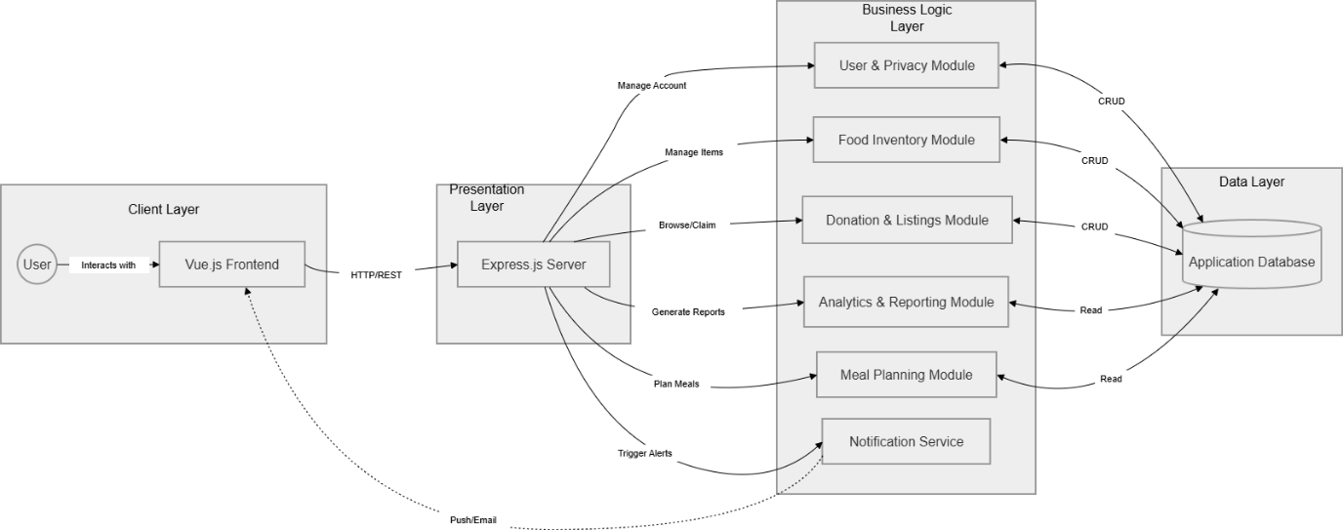
Figure 1.2.1-1 Architectural Design

High level design components

ERD (conceptual view of the data storage)
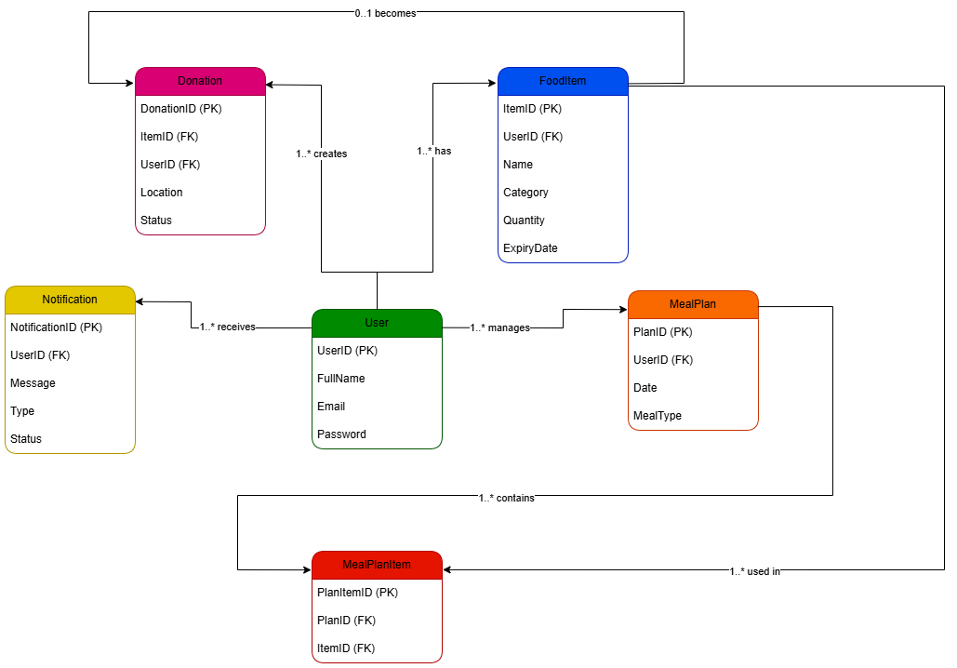
Figure 2.2.1-1 ERD Diagram

Site Map (hierarchy diagram)
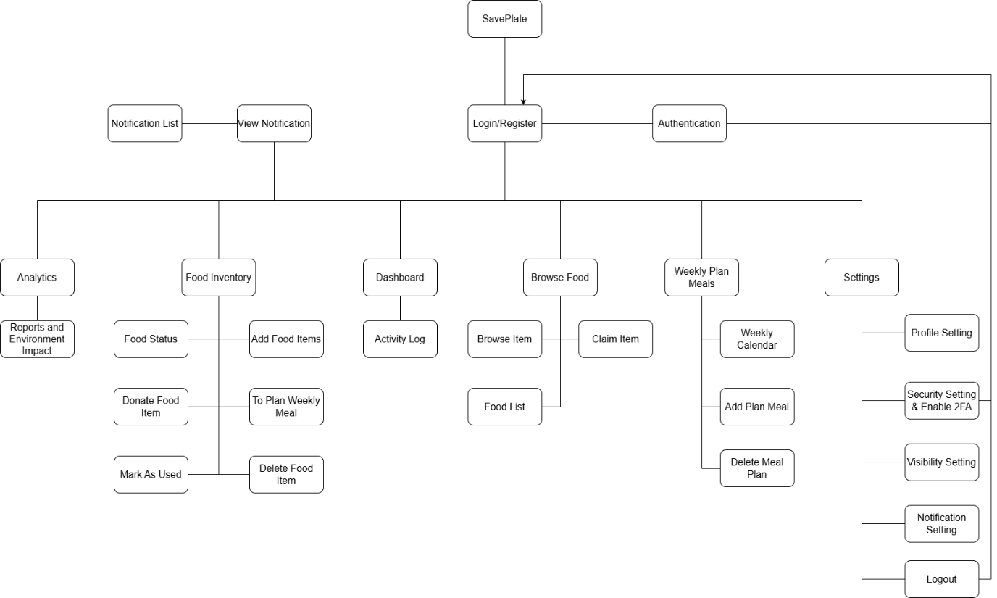
Figure 2.2.2-1 Site Map

Generic User Experience/Wireframe etc – (canva/pencil,figma)
Link to Figma: https://www.figma.com/design/05D3vuF1IRFzOiQsqUVnYV/Wireframe-Design?m=auto&t=uwLD9aNW3uVmNDBl-6
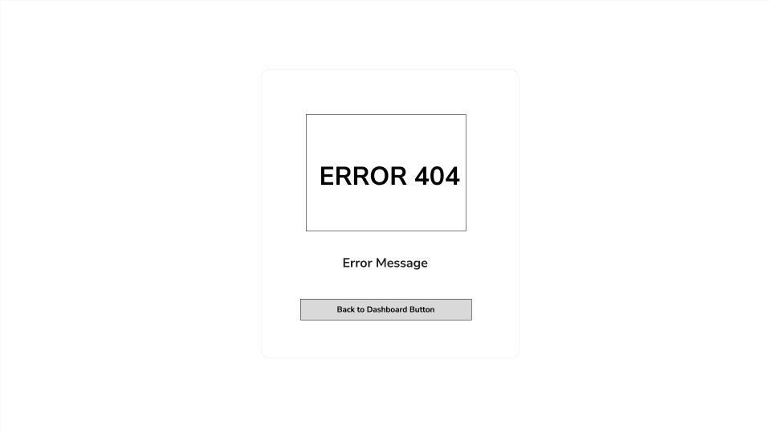
Figure 2.2.3-1 Error Page

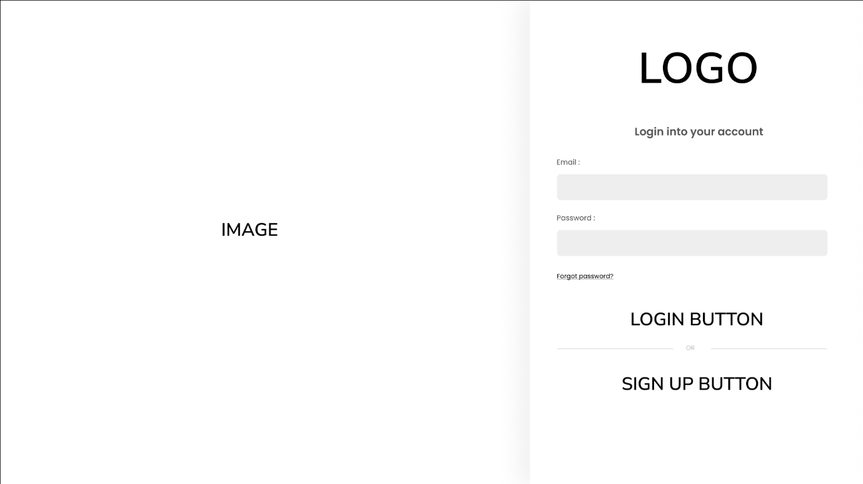
Figure 2.2.3-2 Login Page
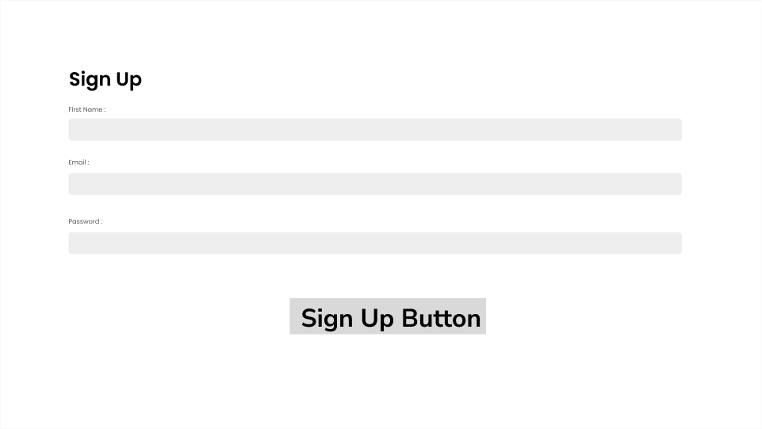
Figure 2.2.3-3 Sign Up Page
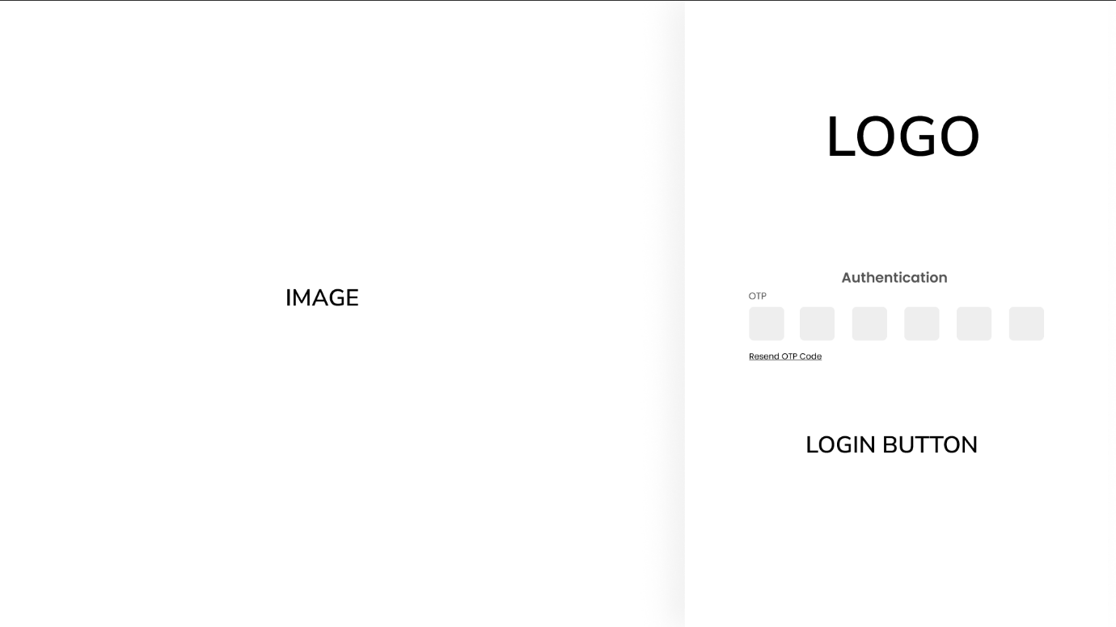
Figure 2.2.3-4 Authentication Page (2FA)

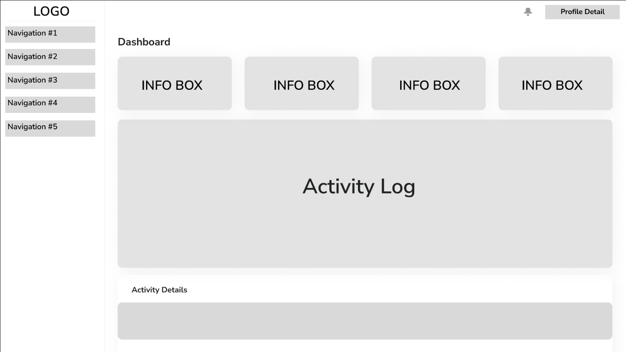
Figure 2.2.3-5 Dashboard
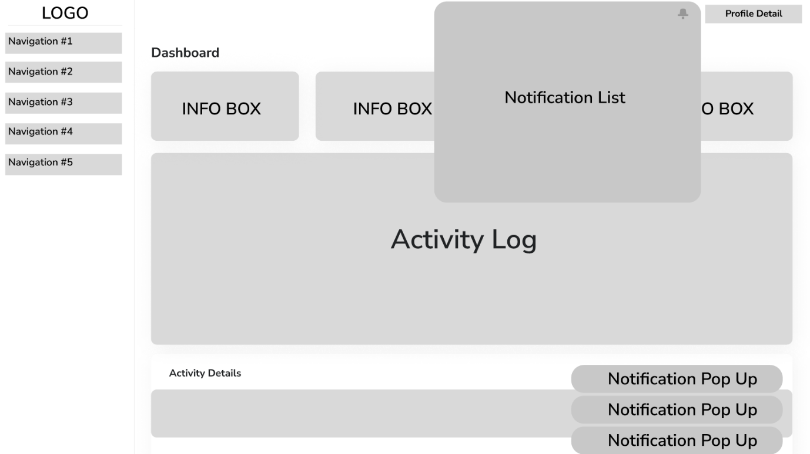
Figure 2.2.3-6 Notification

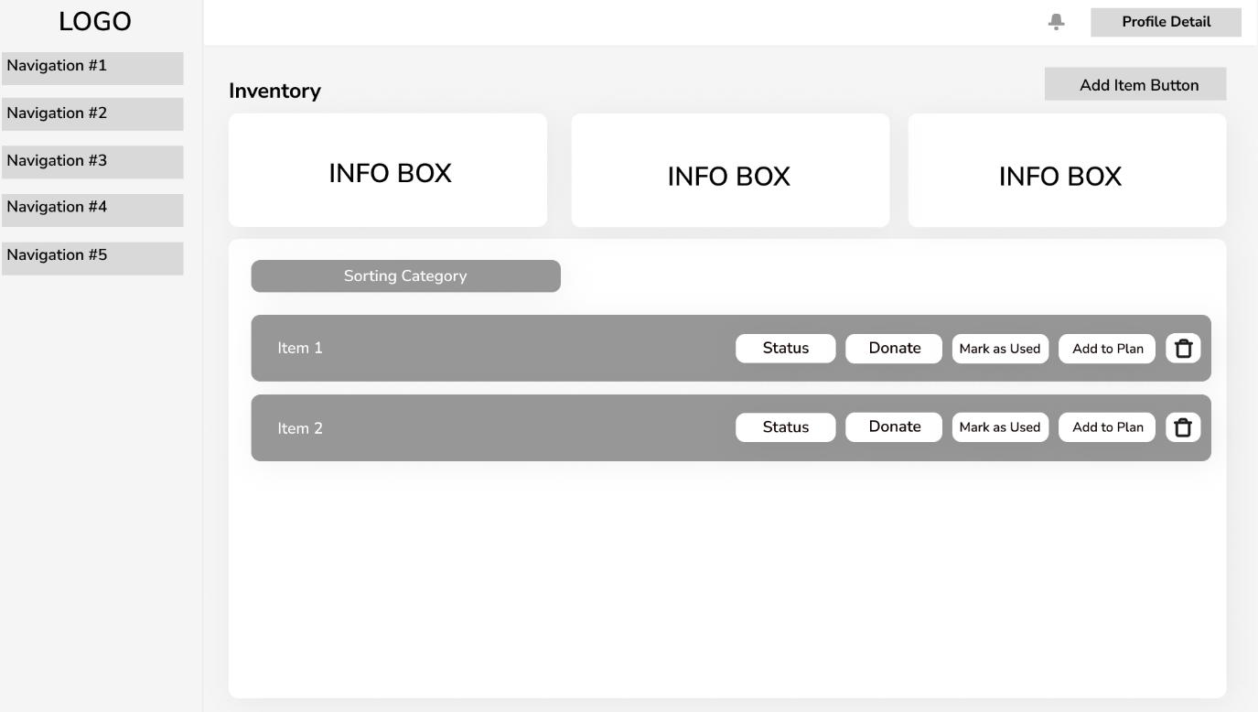
Figure 2.2.3-7 Food Inventory Page

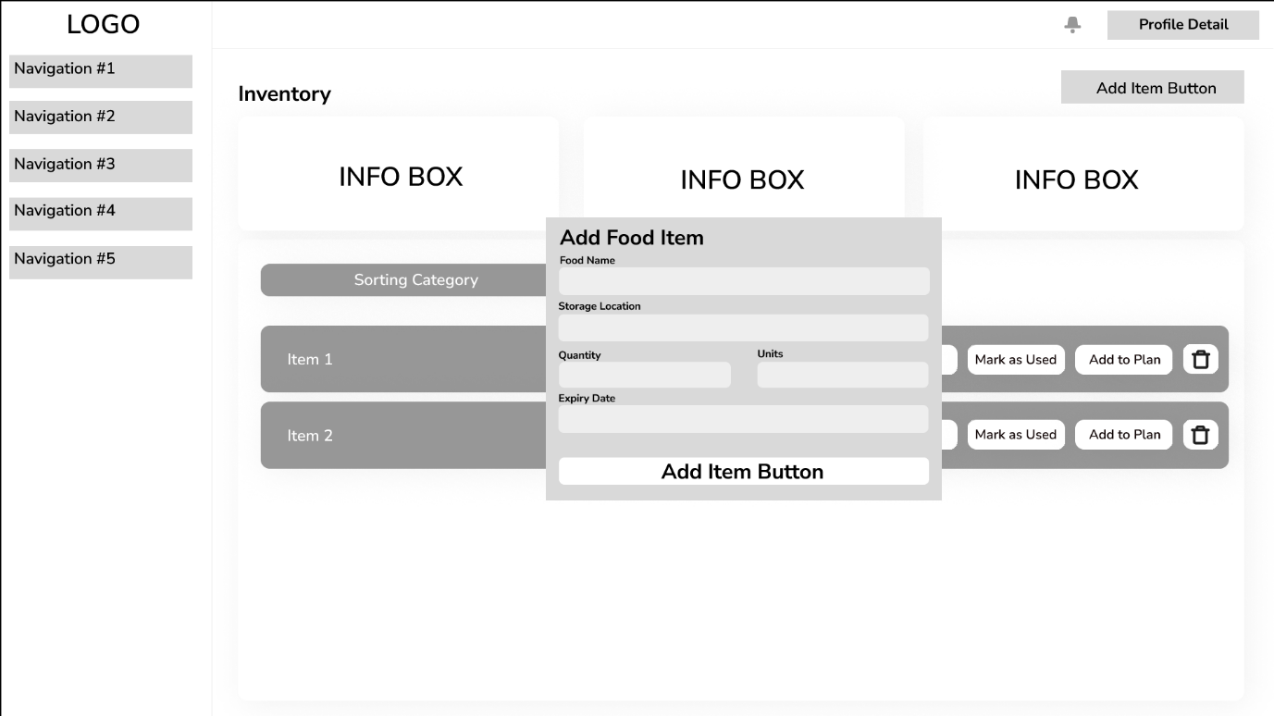
Figure 2.2.3-8 Add Food Item to Inventory

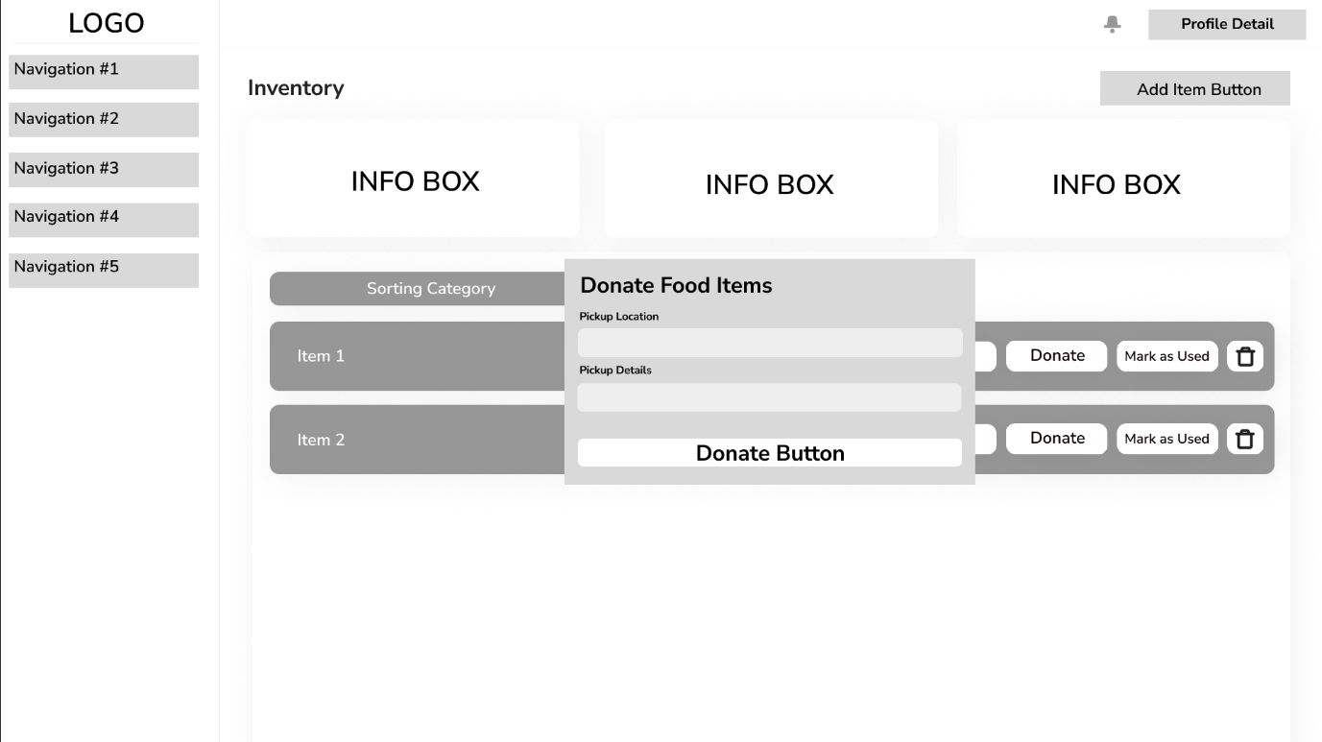
Figure 2.2.3-9 Donate Item from Inventory

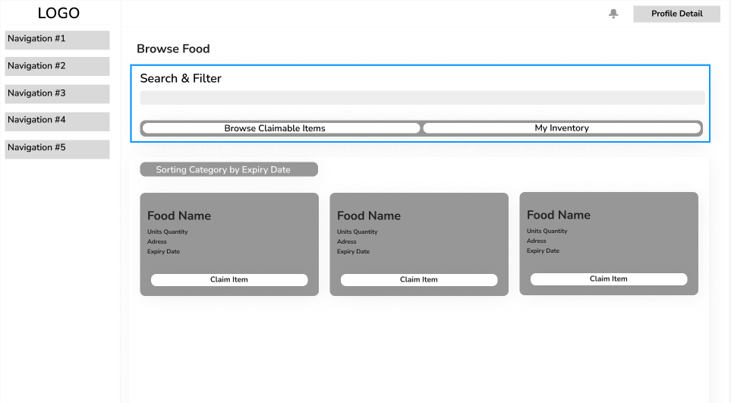
Figure 2.2.3-10 Browse Food Page (Available to claim from another user inventory)

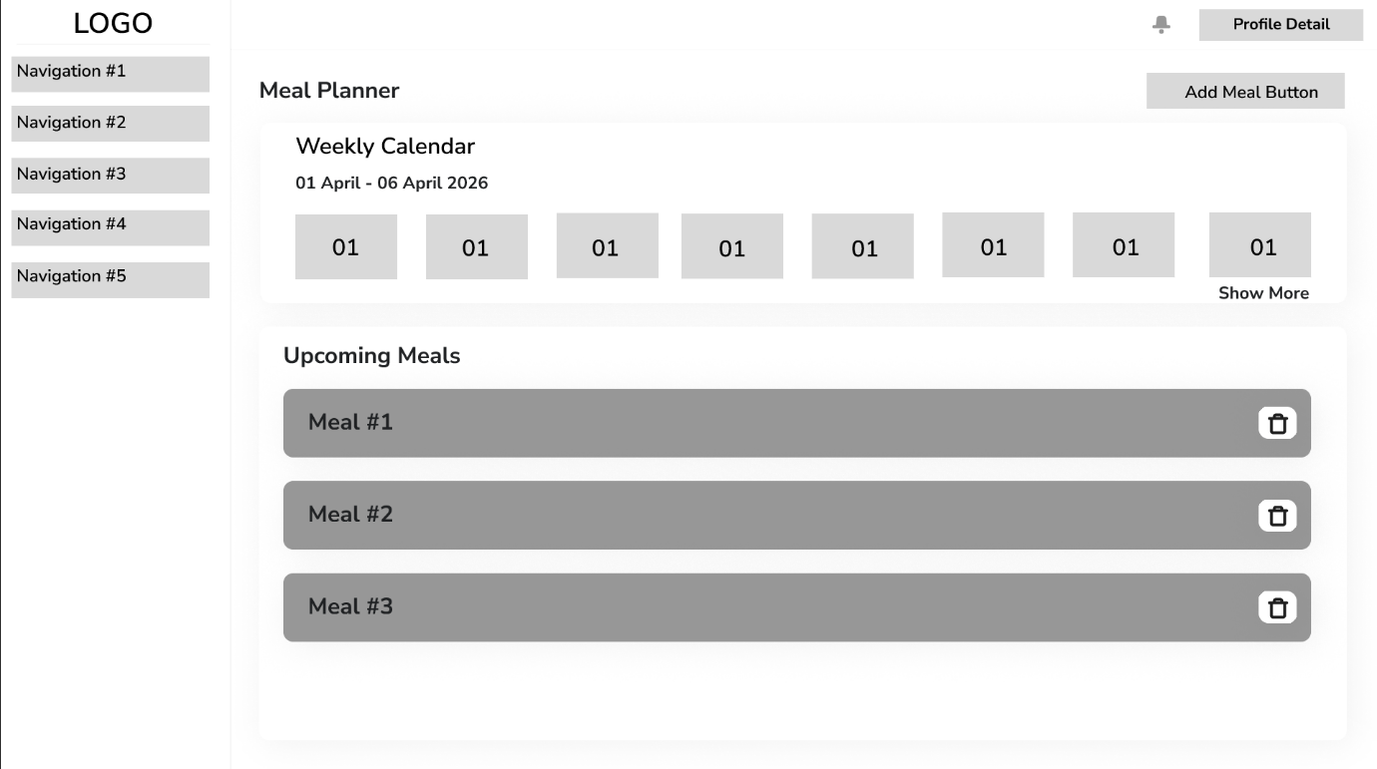
Figure 2.2.3-11 Meal Planner Page

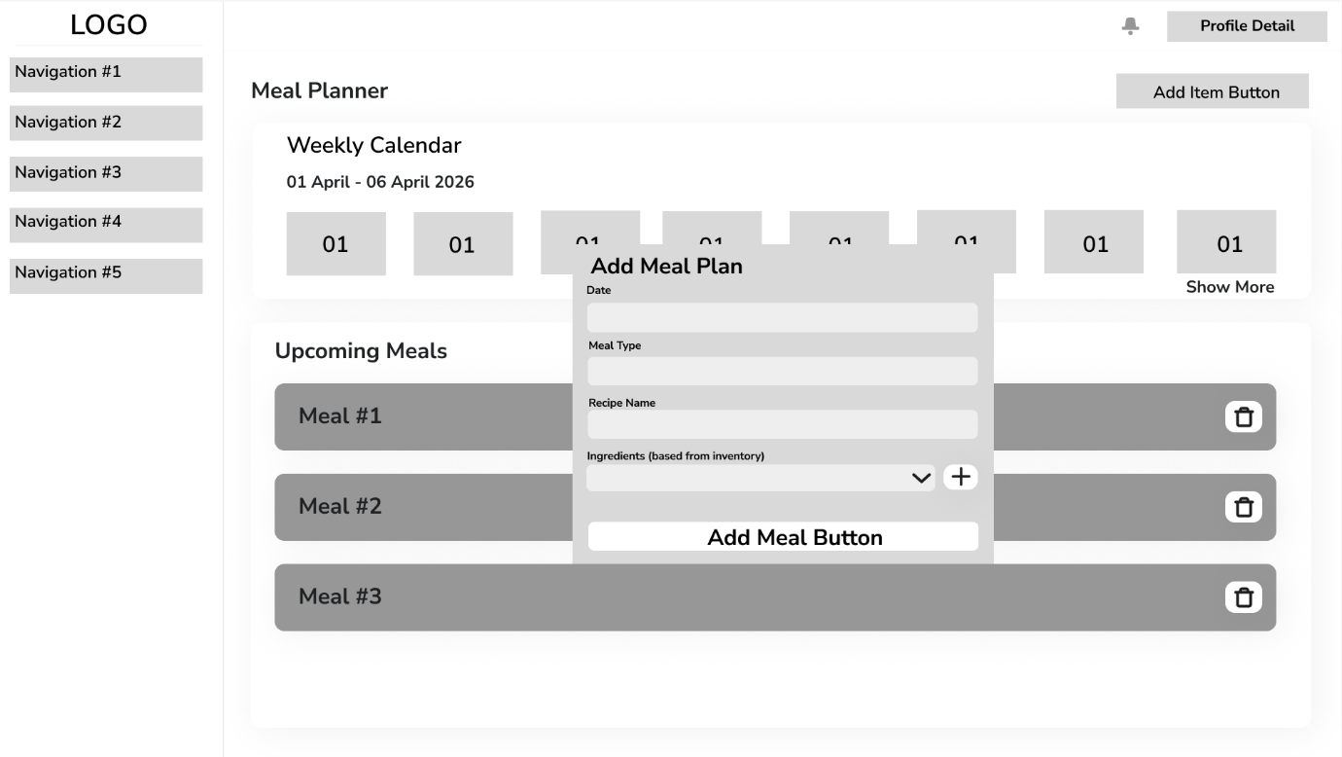
Figure 2.2.3-12 Add Meal Plan (Based from food on inventory)

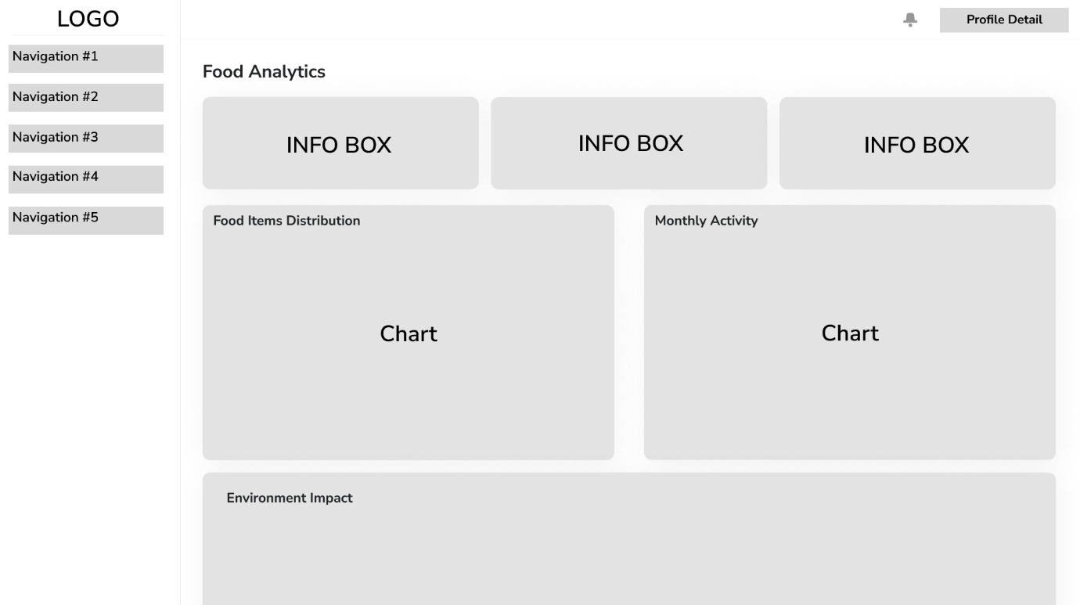
Figure 2.2.3-13 Food Analytics Page (Reports)
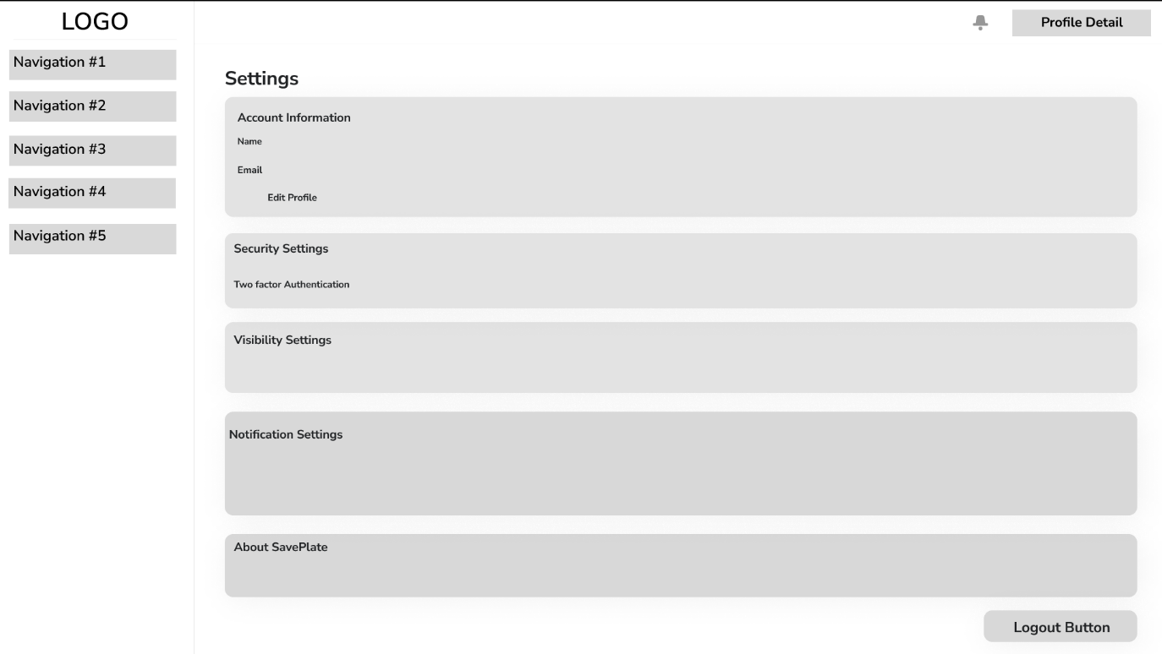
Figure 2.2.3-14 Settings Page

System design of the application

Database Design (Data Dictionary)
This Data Dictionary defines the complete database schema for SavePlate, implemented using MongoDB 8.0 as specified in the Task 1 Technical Description. The schema comprises six entities: User, FoodItem, Donation, MealPlan, MealPlanItem, and Notification. Each entity is presented with its attribute names, key designation (PK = Primary Key, FK = Foreign Key), data type, maximum field size, whether the field is required, and a description of its purpose. Referential integrity between entities is enforced by the Express.js application layer.
Table 2.2.3-1
Entity: User
Attribute Name | Key | Type | Size | Required | Description
userID | PK | number |  | Y | Unique identifier for each household user account
fullName |  | text | 100 | Y | The complete name of the primary account holder
email |  | text | 100 | Y | User's email address used for login, OTP delivery and notifications. Must be unique across all accounts
password |  | text | 255 | Y | bcrypt-encrypted credentials for account security. Plaintext password is never stored or exposed
isEmailVerified |  | boolean |  | Y | Set to true after the user enters the 6-digit OTP verification code sent at registration
is2FAEnabled |  | boolean |  | Y | When true, a 6-digit OTP is required at every login before access is granted. Default: false
householdSize |  | number |  | N | Optional number of people in the household. Used for analytics context
listingVisibility |  | text | 20 | Y | Privacy setting controlling donation listing visibility. Enum: public / community / private. Default: community
showFullName |  | boolean |  | Y | When false, donor name is masked to 'Anonymous Donor' on all public-facing donation listings. Default: true
showLocation |  | boolean |  | Y | When false, exact pickup address is replaced by a suburb-level description in Browse responses. Default: true
expiryAlerts |  | boolean |  | Y | Notification preference, when true, system generates expiry alert notifications for this user. Default: true
donationUpdates |  | boolean |  | Y | Notification preference, when true, user receives donation claimed/confirmed notifications. Default: true
mealReminders |  | boolean |  | Y | Notification preference, when true, meal reminder notifications are scheduled at 7:00 AM per planned meal. Default: true
accountAlerts |  | boolean |  | Y | Notification preference, when true, security-related account alert notifications are generated. Default: true
createdAt |  | date |  | Y | Timestamp when the user account was created
updatedAt |  | date |  | Y | Timestamp of the most recent update to this user record

Table 2.2.3-2
Entity: FoodItem
Attribute Name | Key | Type | Size | Required | Description
itemID | PK | number |  | Y | Unique identifier for a specific food item entry in the inventory
userID | FK | number |  | Y | Links the food item to the specific user who owns it. References User.userID
name |  | text | 150 | Y | The common name of the food (e.g., 'Fresh Spinach', 'UHT Milk 1L')
category |  | text | 20 | Y | Classification for sorting and filtering. Enum: Vegetables / Dairy / Canned / Frozen / Bakery / Other
quantity |  | number |  | Y | The amount of the item currently in stock. Must be a positive number
unit |  | text | 10 | Y | Unit of measurement for quantity. Enum: pcs / g / kg / ml / L
expiryDate |  | date |  | Y | The date the item is expected to spoil. Must be today or a future date at time of entry
storageLocation |  | text | 20 | N | Physical storage area. Enum: Fridge / Freezer / Pantry
status |  | text | 20 | Y | Current lifecycle state of the item. Enum: available / used / donated / reserved. Default: available
notes |  | text | 500 | N | Free-text remarks entered by the user (e.g., 'Opened on 1 Apr')
usedAt |  | date |  | N | Timestamp recorded when the user marks the item as used. Feeds the food analytics dashboard
createdAt |  | date |  | Y | Timestamp when the food item was first added to inventory
updatedAt |  | date |  | Y | Timestamp of the most recent update to this food item record

Table 2.2.3-3
Entity: Donation
Attribute Name | Key | Type | Size | Required | Description
donationID | PK | number |  | Y | Unique identifier for a food donation listing
itemID | PK, FK | number |  | Y | The specific inventory item being offered for donation. References FoodItem.itemID
userID | FK | number |  | Y | The user who is listing the item for community pickup (donor). References User.userID
itemName |  | text | 150 | Y | Denormalised copy of the food item name at listing creation. Remains readable if the source item is later edited
category |  | text | 20 | Y | Denormalised food category from the source FoodItem
expiryDate |  | date |  | Y | Expiry date of the donated item. Used to sort Browse listings by urgency and retire expired listings
location |  | text | 255 | Y | The physical area or address for item collection. Masked to suburb-level if donor's showLocation is false
availability |  | text | 200 | Y | When the item is available for collection (e.g., 'Weekdays 3PM–7PM')
storageCategory |  | text | 20 | Y | Storage type required for the donated food. Enum: Chilled / Frozen / Room Temperature
status |  | text | 20 | Y | Current state of the listing. Enum: available / reserved / claimed / expired. Default: available
claimedByID | FK | number |  | N | The user who has claimed this donation listing. References User.userID. Null until a claim is submitted
claimedAt |  | date |  | N | Timestamp when the first claim was submitted for this listing
donorNotes |  | text | 500 | N | Additional notes from the donor for the recipient (e.g., 'Please bring your own bag')
createdAt |  | date |  | Y | Timestamp when this donation listing was created
updatedAt |  | date |  | Y | Timestamp of the most recent update to this donation record

Table 2.2.3-4
Entity: MealPlan
Attribute Name | Key | Type | Size | Required | Description
planID | PK | number |  | Y | Unique identifier for a scheduled meal plan entry
userID | FK | number |  | Y | The user who created this specific meal schedule. References User.userID
weekStartDate |  | date |  | Y | The Monday (ISO week start) of the calendar week this plan covers. Combined with userID to enforce one plan per user per week
isConfirmed |  | boolean |  | Y | Set to true when the user confirms the plan. Triggers inventory reservation and meal reminder scheduling. Default: false
confirmedAt |  | date |  | N | Timestamp when the user confirmed their weekly meal plan
createdAt |  | date |  | Y | Timestamp when this meal plan was first created
updatedAt |  | date |  | Y | Timestamp of the most recent update to this meal plan record

Table 2.2.3-5
Entity: MealPlanItem
Attribute Name | Key | Type | Size | Required | Description
planItemID | PK | number |  | Y | Unique identifier for an item linked to a meal plan
planID | FK | number |  | Y | Links this entry to a specific scheduled MealPlan. References MealPlan.planID
itemID | FK | number |  | Y | The specific FoodItem being used in this meal. References FoodItem.itemID
day |  | text | 15 | Y | The day of the week this meal slot is planned for. Enum: Monday through Sunday
mealType |  | text | 15 | Y | Category of the meal for this slot. Enum: Breakfast / Lunch / Dinner / Snacks
mealName |  | text | 200 | Y | The name of the planned meal — either typed by the user (custom) or selected from recipe suggestions
isCustom |  | boolean |  | Y | True if the meal name was entered manually; false if selected from the system's recipe suggestion list
reminderScheduled |  | boolean |  | Y | Set to true after the meal reminder notification has been successfully created for this slot. Default: false

Table 2.2.3-6
Entity: Notification
Attribute Name | Key | Type | Size | Required | Description
notificationID | PK | number |  | Y | Unique identifier for a system-generated alert
userID | FK | number |  | Y | The recipient of the notification message. References User.userID
linkedID | FK | number |  | N | The ID of the related record that triggered this notification (e.g., itemID for expiry alerts, donationID for donation updates)
linkedType |  | text | 20 | N | Identifies which entity linkedID refers to. Enum: FoodItem / Donation / MealPlan
message |  | text | 500 | Y | The actual text content of the notification displayed in the Notification Centre
type |  | text | 40 | Y | The alert category. Enum: expiry_alert / donation_claimed / donation_confirmed / meal_reminder / expiry_meal_suggestion / account_alert
status |  | text | 20 | Y | Indicates if the user has viewed the alert. Enum: unread / read. Default: unread
deepLink |  | text | 255 | N | Pre-computed navigation URL to the relevant screen (e.g., '/inventory?highlight=42'). Used for one-tap navigation from the notification
scheduledFor |  | date |  | N | Target delivery datetime for scheduled notifications (used for meal reminder type, set to 7:00 AM on the meal day)
createdAt |  | date |  | Y | Timestamp when this notification was generated by the system

